**­­­ECE3760 Logbook**

**Nick McFaddin**

**Design Entries**

**Design Entry 1: January 16, 2024**

The goal of the design is to make a design that levels the playing field for deaf curlers. In talking with Bob and David, they mentioned that the design should work for an individual deaf curler on a team of hearing curlers or an entire team of deaf curlers. Now considering this, my initial thoughts would be either a visual system using LEDs or a vibration-based system. My next task will be to watch a couple videos about curling to find out more details of the gameplay as well as analyze what challenges a deaf curler may face in comparison to a hearing curler.

**Design Entry 2: January 17, 2024**

After watching a couple videos and reading some articles on curling, I have taken the following information into account.

1. Games can be very long: The games can be around 3 hours long so the device must be able to withstand at the very least that timeframe.
2. Communication is key: The person not throwing the stone is usually yelling out commands to the sweepers, so they know how and when to sweep.
3. Every player plays each position: The device must work for any position as they are constantly changing spots.

Considering this information, I had some initial thoughts about a design. A vibration device may be a good option as the information must be communicated quickly and it would not require the curler to shift their focus to look elsewhere. This would be a strong method of leveling the playing field. The device would have to have different modes, one for each position with the amount or strength of the vibrations signifying different commands.

**Design Entry 3: January 19, 2024**

During class today, we saw many of the components that would be available to us for materials. LEDs were common amongst the devices we would have access to, but vibration devices were not. This was good to know at this stage of the planning phase as it is easy to shift my focus to a more visual device because I haven’t spent much time on the design yet.

Thinking about it in a bit more detail, the only 2 positions that really require aids are the sweepers. The person releasing the rocks is pretty much relinquished of their responsibility once the rock is released. The person giving the callouts doesn’t really need assistance as they are able to see everything and just must communicate that. The sweepers on the other hand, must focus on sweeping, and running down with the rock. I can only imagine that trying to look down at the rock while looking back to see hand signals on the weight and person that should be sweeping would be an immense challenge. To level the playing field, the goal would be to make a device that would eliminate the need for the sweepers to take their eyes off the rock and the ice beneath them. We could have an LED system that lights up on the broom with different colours, corresponding to weight and if that sweeper should be sweeping.

**Design Entry 4: January 23, 2024**

With the initial design review and specifications being due over the course of the next week, I did a little more thinking in terms of a device we could create for our design. I thought further on the idea in my previous entry and in discussing with a couple of my team members during class, I thought that a device that straps onto the broom via Velcro or some other re-attachable device would be the best suited for this project. I know that just like a hockey player likes to have a specific stick, a curler would be similar with their broom, so it should be a device that can change brooms so that multiple people on the team could use it if need be. The device would light up different colours just as I mentioned in the previous lab and could possibly flash at different rates depending on the severity of the sweeping force. The skip (person calling out the instructions) would have a remote that would be able to signify to the sweepers who is sweeping and what severity. I think taking this plan to action gives us the best chance at leveling the field for deaf curlers.

**Design Entry 5: January 27, 2024**

During a meeting with my team for the design project Friday, we talked about some design solutions. Our group talked about vibrations briefly as a method for communication but ruled that out as it may be difficult to distinguish the difference between a small, medium, and large magnitudes of vibration. Thus, since a haptic system was ruled out, we were now decided on using a visual cue. Initially, ideas were brought to the table regarding flashing of the LEDs at different rates, however this was ruled out as on top of being a terrible idea for epileptic users, it may be hard to recognize when the broom is being shook at a rapid rate. This brought us to the idea we are currently pursuing which is a color scale LED system. Using a scale with orange-blue-black (not a final colour scale, but removes red-green colour blindness), to represent light, medium and hard magnitude of sweeping respectively, the sweepers can look down at the device on their broom that may either be on the head of the broom or attached via Velcro or other attachment mechanism on the shaft of the broom. The skip would have a remote-control device with a simple communication protocol so that they would not have to be constantly looking down and must go through multiple steps to communicate with their sweepers. Instead, they could use an analog stick, linear potentiometer, or something else of that nature to adjust the sweeping magnitude without having to look in multiple places at once, thus allowing them to focus solely on the game.

**Design Entry 6: January 28, 2024**

Today I am writing the specifications for my team’s initial design review. I volunteered to take the first crack at it as I thought it would be helpful to have one person completely done their specifications so that the others would have time to look at it, review it and then use similar concepts and ideas when making theirs. In addition to this, for the people in our group who are speaking for the initial design review presentation, it may inspire a couple extra speaking points. Throughout the specifications, I challenged myself to think empathetically, which is easy to say but often hard to act on. It is easy to think about what may cause someone else an issue but not actually bat an eye when they are going through that struggle. This project gives me a sense of pride in knowing that I can design something for someone that might really improve their life in a certain aspect. Not only for this design, but empathetic designs in the future as well. It is a great foundation to lay down early on in my hopefully long-term career and should act as a terrific experience to work alongside others who share this same empathy.

The constraints I thought of mostly related to the frustrations a player may face having to constantly look back and forth between their communicator and the task at hand. I know for myself, if someone put earplugs in and told me to play one of my sports (ultimate frisbee and hockey), that I would struggle immensely. Team sports require communication, it is one of the largest facets in the game, so I tried to touch on how this communication is currently very difficult for deaf curlers and that our end goal is to create a level playing field by streamlining their means of communication.

Our plan as of this moment is to have some sort of controller, preferably one without a bunch of options and buttons as this would take attention from the skip. We want it to be as simple as possible to facilitate communication, but still be cheap to build and easy to use. In doing this, it can be accessible to everyone and easy enough to use that it would not require much of a learning curve. We would couple this with a simple LED system, with a colour-blind supported colour scale to promote inclusion in sport and attach this somewhere on the broom that would always remain in the user’s field of vision. With our challenges, constraints and goals laid out, the specifications were complete.

**Design Entry 7: February 1, 2024**

Today we were tasked with two new assignments, the LTI assignment and the Data Flow assignment. The latter is an assignment that required us to create a data flow diagram for both the skip’s communication device as well as the sweeper’s. This got me thinking about some of the things we would need for each.

Starting with the skip’s device, I found a resource on the slides that had a solid data flow diagram already built. I used this as my template, but quickly realized that some of the components of this data flow diagram were overkill, particularly the accelerometer. This component measures the acceleration of an object or device. This shouldn’t be something that we need going forward as the current plan is to allow the skip to manipulate a couple linear potentiometers to dictate the sweeping force of the sweepers. Thus, I removed the entire chain of accelerometer components and drivers. Doing this allowed me to remove the fusion processing as well, as that was only needed to retain the output of both the potentiometers and the accelerometer. This gives us a much simpler data flow diagram and one that should be more realistic for our project.

I used this data flow diagram and reversed it to create the data flow diagram for the sweepers. This allowed for a simpler path as the LEDs don’t require a driver. This meant that we just needed some sort of visual processing to take place between the packet processing and the visual device.

This concluded the creation of the data flow diagrams, which I found very helpful as it gave me insight to how simple most of the components of this design should be. With a good protocol implemented and executed via code, the design does not have to be super complex to be effective. It can be simple, and simple may be better as it will allow for faster and easier communication which is imperative in a game where the speed of communication makes a world of a difference. The goal for our group will be to get effective messages communicated as quickly as possible from skip to sweeper. If we can match the speed of a verbal cue with our system, this would become a realistic implementation in a real-world setting.

**Design Entry 8: February 7, 2023**

After the completion of lab 2, we now have experience with the ESP-Now protocol that allows our ESP32 devices to exchange information. With all its capabilities, it will be the protocol that we use for our design prototype at the very minimum.

During class today, Bob talked about some of the ideas that people had brought up in the initial design review that would be either difficult to implement or hard to use. One of these stood out for me and it was that an Xbox controller type of design for the skip device would make it difficult for the skip or whoever was communicating with the sweepers as they too can use their broom and assist with the sweeping if the rock is moving slow enough. I hadn’t thought about this flaw in my design plan so that got me thinking on some other ideas as our team has a meeting Friday to get together an initial pitch so we can order some parts.

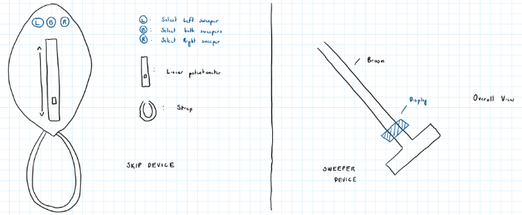

My idea that I am now pivoting onto is a single hand implementation that has buttons to click. The requirements for this device include being able to select which sweeper to communicate to as well as an intensity function that determines how hard to sweep. The image on the left above depicts how I would arrange the buttons on the controller.

The 3 buttons on the top indicate if the skip wants to communicate with the left sweeper, the right sweeper or both. Then the linear potentiometer sets the intensity and is paired with an LED beside it indicating what intensity is being coordinated with the sweeper.

On the sweepers side of things, the design concept has not changed much. It is a device that will attach to the broom shaft and have a display of LEDs coming from it that will indicate to the sweeper if they should be sweeping and what intensity they should be doing it at.

**Design Entry 9: February 9, 2024**

Today our group met to discuss our design ideas and to nail down a parts list so we could order our parts and have them before reading week. We listened to each group member’s ideas and put together our overall thoughts to what we thought was our best idea.

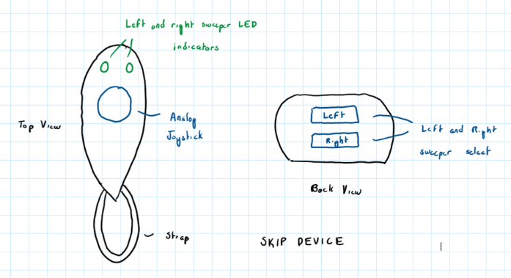 For the skip device, we thought using the design of a Wii Nunchuk would be the best way to have a single hand device that has easy implementation. Two buttons on the back that could indicate left, right or both and an analog joystick on the front that determines intensity. Through using this design, we ensure simplicity for the skip and quick communication through fast commands that are easy to click and access. On the device, we will have LEDs assigned with the left, right and intensity so that the skip can double check if need be that they’ve communicated the correct action. The intent is that these LEDs help them to learn how to use the device the first time or two and they can transition away from it and no longer must need to look down to ensure that the device is communicating as they are intending.

The sweeper device on the other hand did not change much from our previous designs. Now that we have worked with the Neopixel ring, there is a similar implementation on a straight line of LEDs rather than a ring shape that we plan to implement. This line formation of LEDs can sit on top of the ESP32 and then have a lithium battery underneath as a power supply. This will still be attached to the broom via Velcro or strap and have a display of lights or individual LEDs that come off it to make it easy for the sweeper to see and interpret in a high stress and fast paced environment.

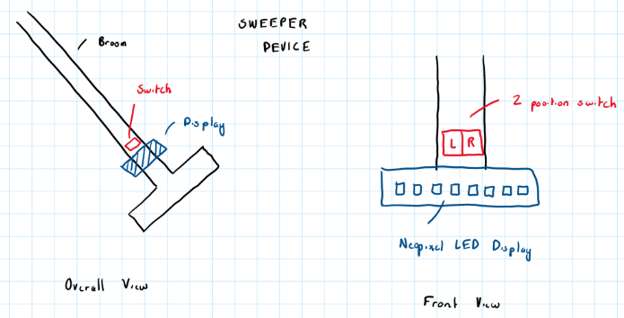

**Design Entry 10: February 12, 2024**

Today I made a draft of how the sweeper Statechart may look for our groups design. Below is the UI that I finalized.

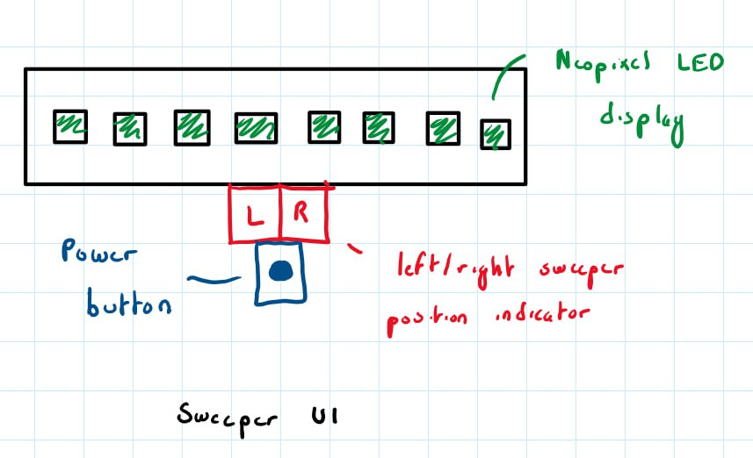

On the display, we have our single line Neopixel LED display which will indicate red, yellow, green or blue for high, medium, low and standby intensities respectively. The left and right position indicator will decide which sweeper this sweeper is and will accept that signal when transmitted to from the broadcast. The last thing we added was a power button as the sweeper device had no way to turn itself on and off before. Ideally, we could turn this into a feature that utilized a pattern on the sweeper position slider to turn the device off and on to limit the hardware aspects of the design but that can be refined later.

Following the UI design, I created the first model of the Statechart by hand based on the Statechart of the watch we were given. The 3 main parts of this design are the power button, LEDs, and left/right position switch. The LEDs and left/right switch can work simultaneously; thus, they are AND’d whereas both of those components can only work while the power button is on thus they are EXOR’d. After doing this I worked on the power button and left/right switch sections. These states were easy as there were only a few possible states that they could enter. As for the LEDs, they start off, then logically, when it turns on, we want to have some sort of indication that it is turning on, give it a couple seconds to connect to the transmitter and then signal that it is in a standby mode waiting for a command. The blinking and blue states represent the connection delay and the standby respectively. From here, we can enter the high, medium, and low intensity states through the adjustment of the position of the analog stick. Following this I wrapped the entire thing in a main-component section which was controlled by if the component was dead or had a working battery. This completed the initial design of the sweeper Statechart.

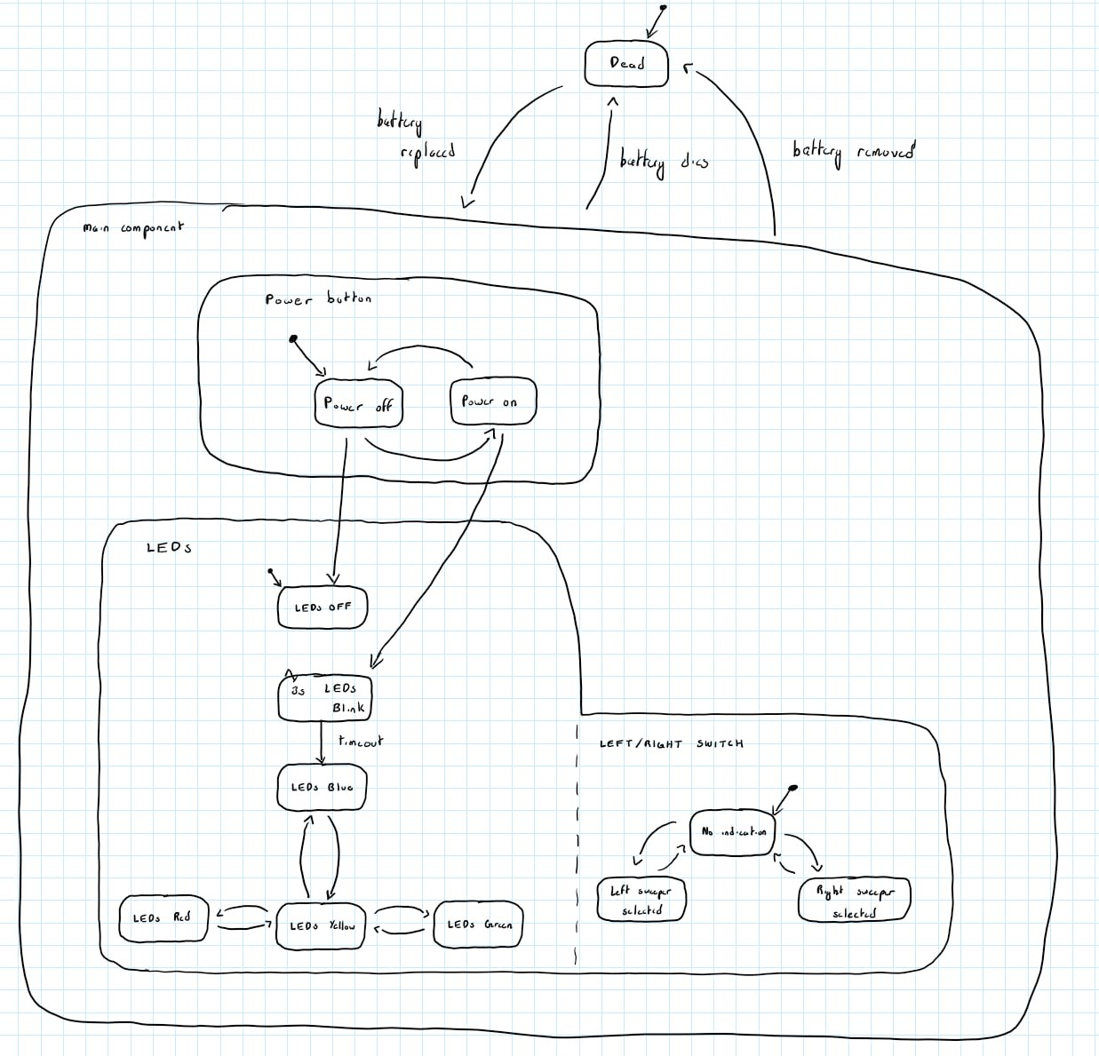

**Design Entry 11: February 14, 2024**

Today, our group finalized the Statechart designs for both the skip and sweeper. Below is the new UI design for the skip device. Using our Wii Nunchuk design we have two sweeper buttons that indicate which sweeper we want to communicate with, a removeable panel that encloses access to our battery and ESP32 components, an analog stick that indicates the intensity at which the sweeper should be sweeping at as well as a corresponding LED that indicates what each sweeper is currently seeing on their display.

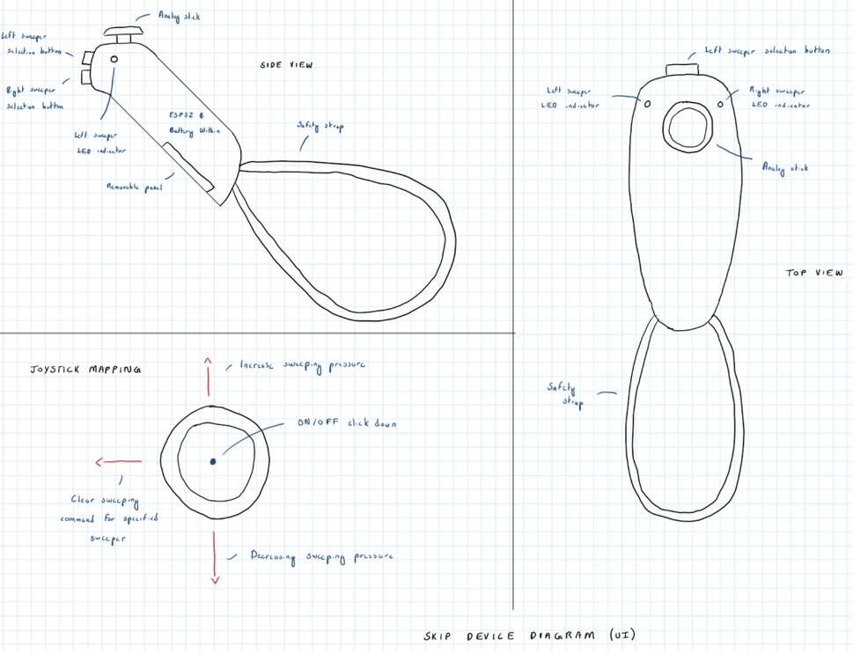

Following this is an image of the skip Statechart.

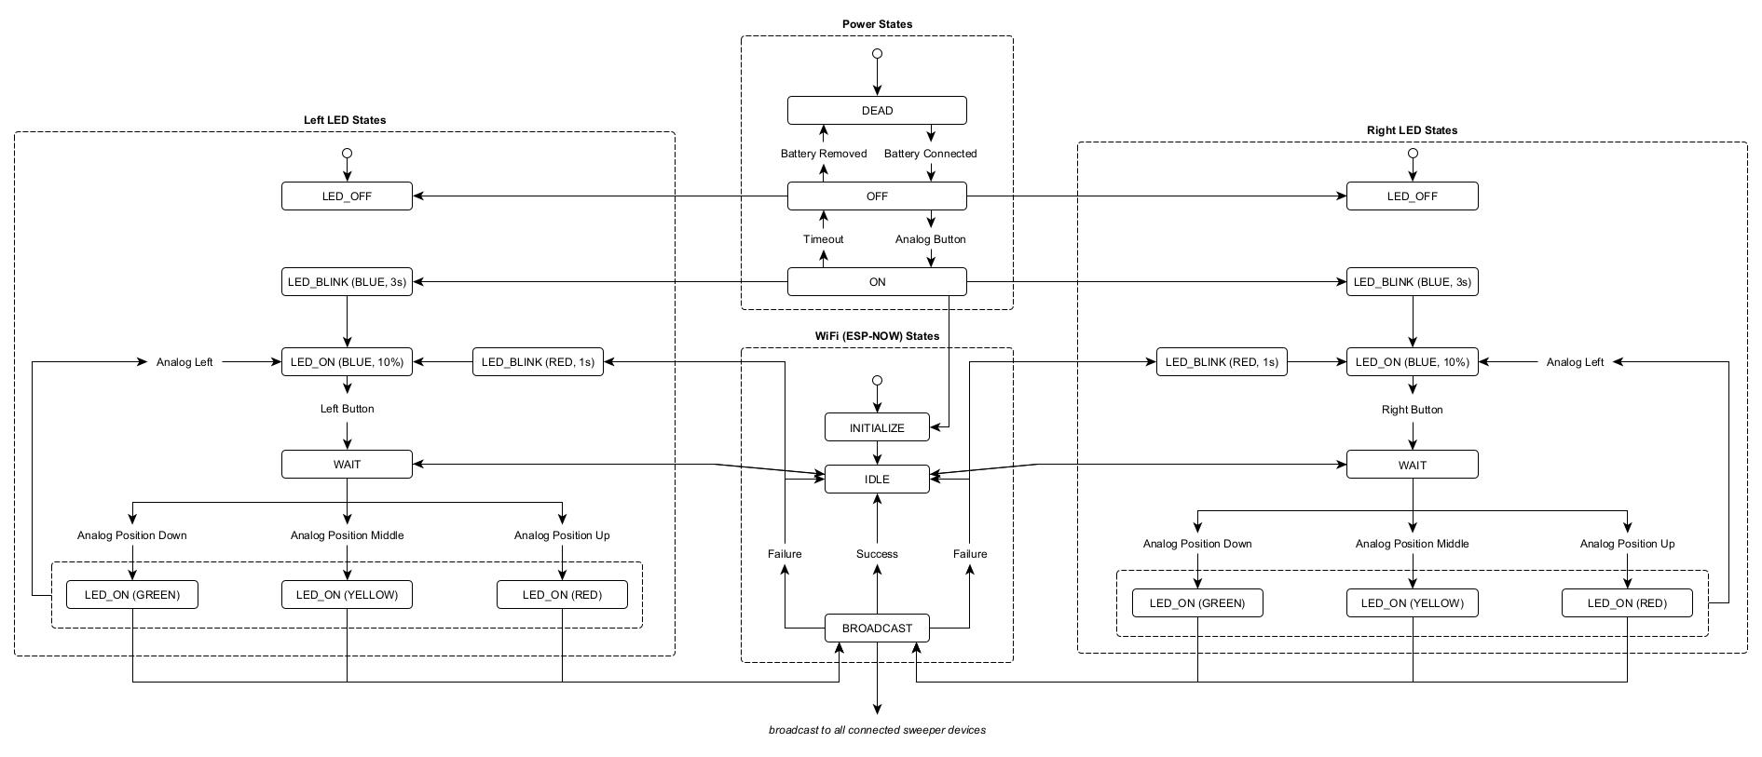

The skip Statechart has 4 main sections, the left LED state, right LED state, power state and ESP-Now state. To begin, the device has to be on, thus all functionality starts with the analog button being clicked in to power on the device. From here, the right and left LED states indicate a connecting state, followed by a standby state while ESP-Now is initialized. From here ESP-Now idles while the right or left sweeper is selected for communication and then the selected side’s LED transitions to a wait state where it will wait until an ESP-Now broadcast success occurs and then indicate what level that the analog position on the skip device is at. On a broadcast failure, the LED indicators flash red to let the skip know that their command did not transmit properly and then prepare to send another command after going through the standby and wait states.

The updated UI design for the sweeper has very few modifications. Overall, it is the same as the previous entry but with an added view of the attachment mechanism we will use to attach the device to the broom. We haven’t yet decided if the mechanism will be a clasp, Velcro or some sort of screw in attachment but we are leaning away from the original Velcro idea as we don’t think it will be able to withstand the intense shaking of the sweeper. The last adjustment we made was to add a similar removeable panel that the skip device has to encapsulate the battery and ESP32.

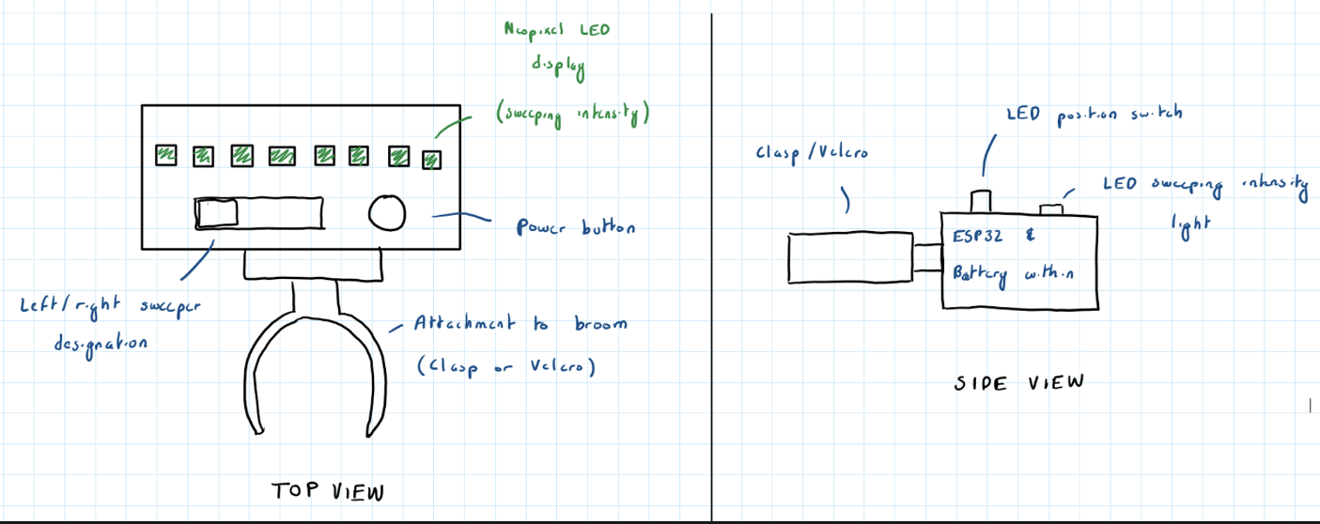

Below is the Statechart for the sweeper device.

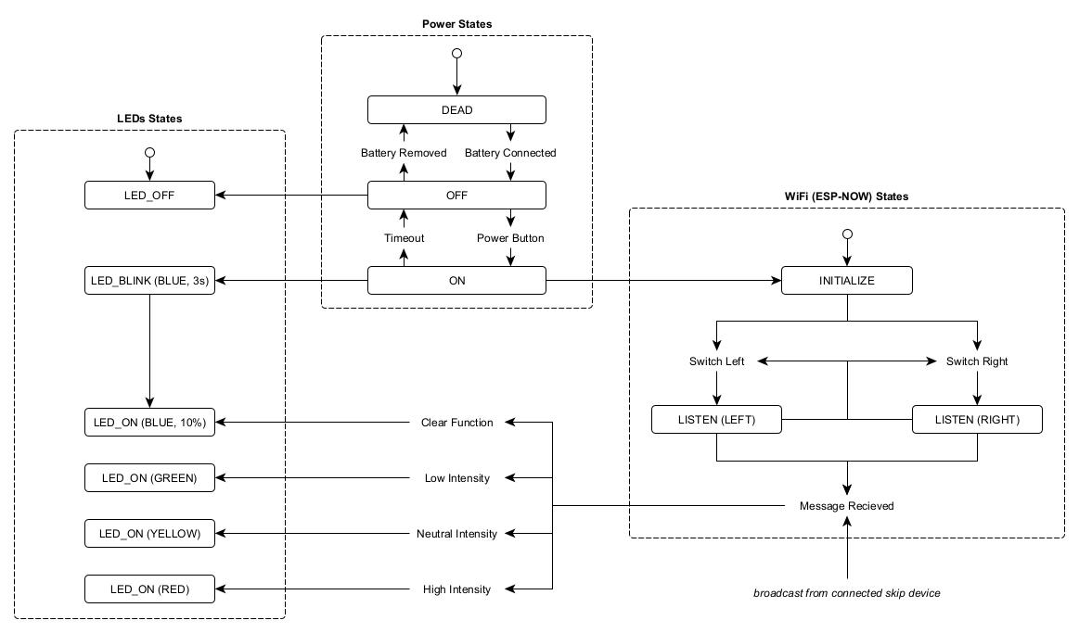

The flow begins the same as the skip device, with the battery being dead and the rest of the components only entering their initialized states once the power is turned on via power button. Once the power is turned on, ESP-Now is initialized, and idles while the LED display signals connecting and then standby. Once this setup is complete, the device listens for commands based on which sweeper it selects. This command is received and then it determines the colour of LED based on the packet data. This concludes the process of both of our device’s.

**Design Entry 12: February 16, 2024**

Today David went over the PCB assignment that we would have to complete and did an example in class on EasyEDA. I chose to follow along as I felt that this would give me a good starting point when picking up this assignment again down the road. I tried to pick most of the same components he did for simplicity as it would be easier to follow along with a carbon copy of his project.

After the class was done, he had shown us how to create the schematic, convert it to a PCB and view it in 3D mode. As of right now I am very close to being done the schematic but have not yet completed the conversion to PCB as the schematic is incomplete. Will revisit another day.

**Design Entry 13: February 17, 2024**

1 day into reading week, Kameron and I have coordinated to meet at the school on February 20th (Monday) to work on an initial build for the skip and sweeper communication. With all our parts in, as well as the additional parts that Kameron and I both have from Arduino starter kits, we should be able to put something together. I made a small agenda for what I want to get done during that work period.

1. Connect the two ESP32’s so that we can transmit analog position from one to the other and display a colour based on its position.
2. Determine the logic of holding a command for a sweeper once we swap.
   1. Ex. If I give the right sweeper the high intensity sweep command and I swap to the left sweeper, will that command be retained or cleared.
3. Determine the logic of the clear command. (How we want to retain/clear)
   1. Ex. If I have previously given a command to the left sweeper and I am now on the right sweeper and I click clear, will it clear commands for just the selected sweeper or both sweepers.
      1. Initial thoughts: Should make left analog position to be clear for selected sweeper and right analog to be clear for both sweepers.
4. Put together a small demo video or series of pictures to show the rest of the group members and have an idea that we can take to a PCB model.

Will report back here on the 20th to record progress from the meet up/work period.

**Design Entry 14: February 20, 2024**

Today I met up with Kameron to work on the project. We were looking to get a working prototype going by the end of the week so today would act as a good starting point for that.

First, we worked on using small buttons that had 4 pins as our buttons for selecting which sweeper we wanted to communicate with but shortly after, decided that the big buttons that we had ordered in our parts order would have a larger touch radius and create less error. Following this, we integrated the buttons in with our 4 pin LEDs (ground and RGB pins). First, we used a Boolean array to hold the state of each button. The delays we were using as well as the constant changing of this one array created lots of problems for us and we determined that we would have to pivot on our implementation of this concept.

This brought us to try edge detection. In doing this, we created a loop that used a current value and last value to identify the transition as rising or falling and only make a state change on a proper transition. Although it sounded intuitive, it still needed more work as we were lacking in the response time department and for this project, response time is one of the key metrics in which will determine how applicable our device could be in a real curling game setting. By removing the delay, we increased our response time drastically but still found we were getting errors on button holds and quick button presses. This changed once we implemented a last, current and state value array. These 3 arrays controlled the flow of our button presses extremely well and allowed us to carry out our commands with no issues.

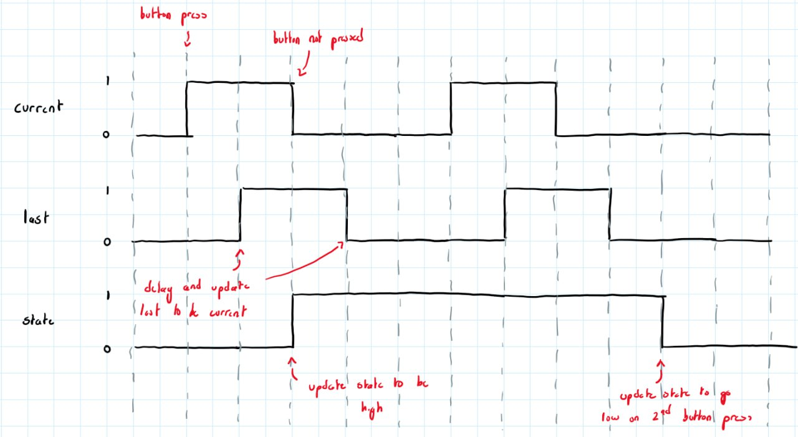

Above is a diagram of how we implemented these 3 variables together. The current value represents each press of the button, and the last value holds the value of the current value once it has been determined that they are different. Once this change has been made, the state is updated to be the opposite of whatever it currently is. This state reflects if that button’s sweeper is selected or not.

Once this implementation was finished, all we had to do was connect the joystick to our circuit. First we set up the joystick using jumper cables and attached them to GPIO pins of the ESP32 board. We quickly found out that these GPIO pins were not ADC inputs so we had to revise our pin selection before continuing. The x-input of one of the ADC input pins was skewing our median to be 3000 rather than the regular ~1890 value that we had gotten in the lab. Once we swapped to another pin we got the right value but we are not sure why that value was skewed so that is something we will have to revisit.

Following this, as mentioned in the Lab 2 entry of the logbook, our configuration of x and y was messy as up and down and side to side did not coordinate to how a regular cartesian plane would look. Thus we swapped the x and y inputs to correspond to each other which gave us an easy to work with Cartesian plane, thus making it simpler when we went to decipher these numbers and map them to colours going forward. In addition, the wires of the joystick are now attached on the bottom which should make it easier to fit in the casing that we envision we are going to use. A diagram of our old vs new mapping is attached below.

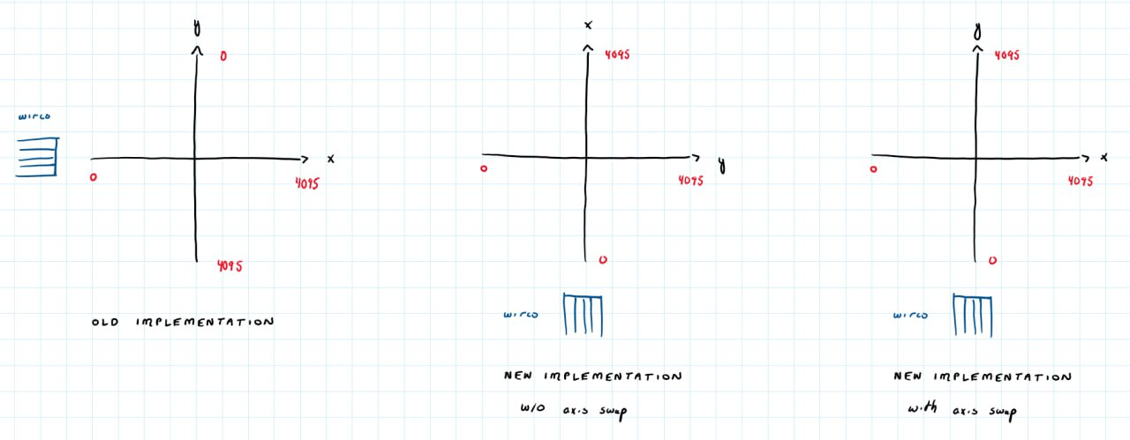

Next, we used a moving average filter to smoothen out the readings of the joystick. This made for more gradual transitions. We soon decided that this would be a bad direction to take as it delayed the response time which was imperative to having a good protocol.

Then we talked about future logic in having the skip do all of the colour interpretation on its end and sending over only a minimal packet that contained which sweeper it wanted to address as well as the colour it wanted to display. Kameron agreed with this and so we decided this would be our framework for our communication protocol. Lastly, we used the left and right positions on the analog joystick to represent a clear function for the left and right sweeper respectively. All of our intensities and clears relied on thresholds that we defined to be ~1000 off of the most extreme value (1200 for lower threshold and 2800 for upper). We added or subtracted 900 as a clear threshold to the upper and lower thresholds respectively as to limit the amount of error and delicacy of our clear function, and with this fix, the first model of our skip device was complete.

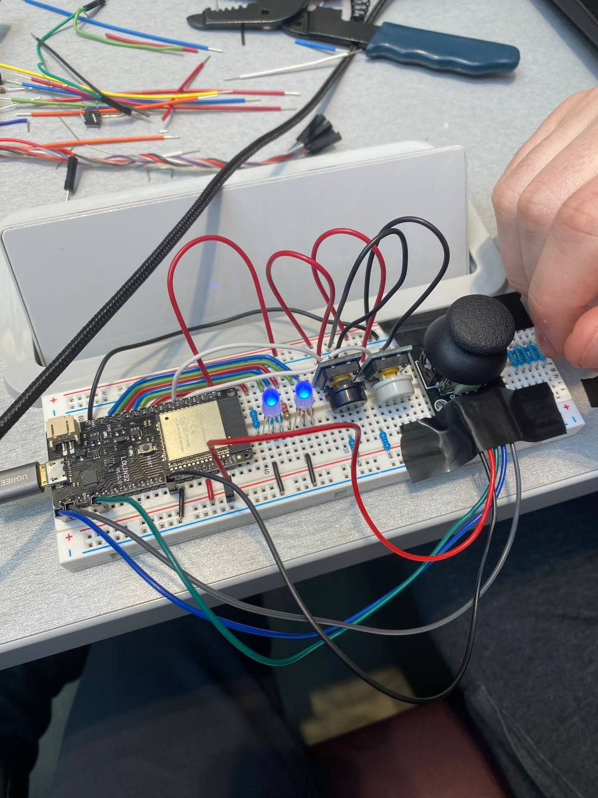

Kameron and I had a brief chat about using a colour scale in future models of the design rather than having 3 distinct colours. We both agreed that this could be beneficial in allowing the user to gradually increase or decrease pressure rather than being limited to a subset of 3 commands. We left this to a future model as the working prototype we had now was sufficient and we wanted to take some time to figure out how we would do this RGB scaling as we are going from a green to red scale thus making it difficult to do a solely numerical value scale. Also, as a side note, we want to have a discussion with our group about what colour we want to use as a high intensity and which to use as low. We are unsure what conveys better as in my head, a red colour signifies urgency while as others may think that the green is more urgent as that represents “go” in a traffic light design.

Following this, we moved all the components to be attached to the board in a nicer fashion rather than being attached via loose wires or jumper cables which gave us a bit of a refinement. Now that we were done the skip prototype, we were ready to transition to the sweeper device in our next work period.

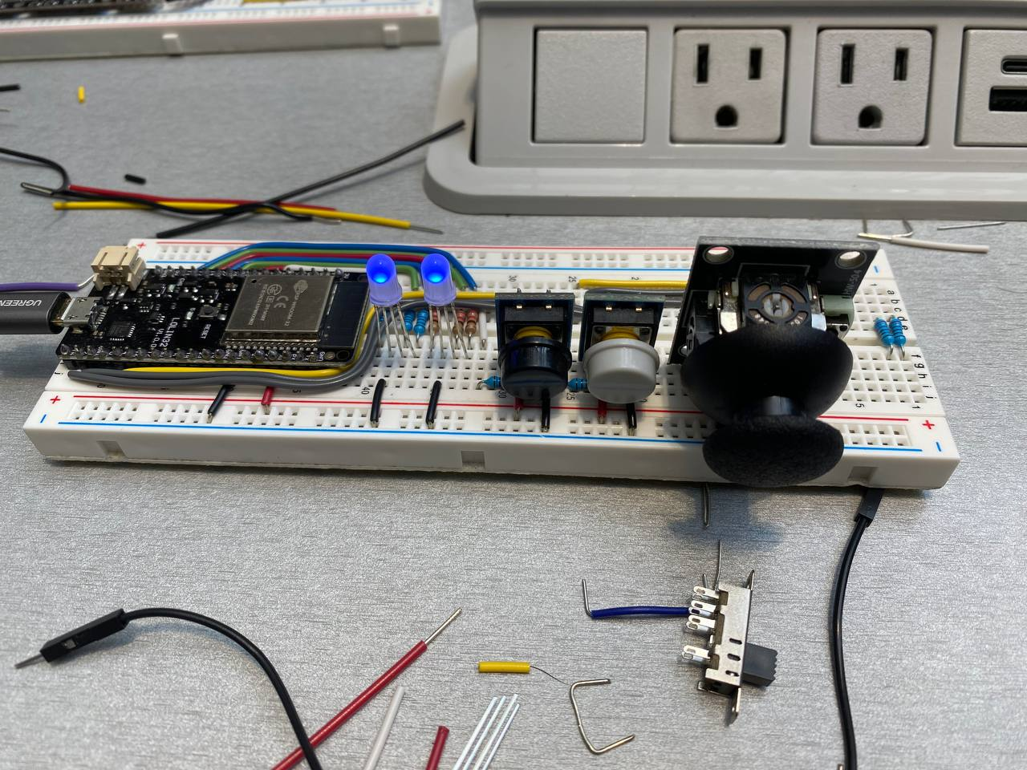

**Design Entry 15: February 23, 2024**

Kameron finished the first model of the skip device which transmits the same colour emitted on the skip LED light to the Neopixel line of LEDs on the sweeper device. As of right now, the sweeper device listens to communication intended for either sweeper. We will have to revise the sweeper device to listen specifically to the communication that is intended for the sweeper it has selected. This shouldn’t be too hard to do. With this being done, we would be finished our first prototype that we would be able to show during the second design review during class. In addition, this will allow us to create our PCB’s and begin to create the casing for our devices and focus on attachments.

Today, I was specifically thinking about attachments and for the skip, it is fairly simple as we have agreed upon having a safety strap, much like the Wii Nunchuk already had. For the sweeper however, there is a debate to be had. We could either use some sort of clasp that snaps on to the broom or use a screw in type of attachment style where there would be set screw locations that you could tighten the device around the broom at, thus allowing for flexibility while still having rigidness and a non-shaky device. Personally, I think we should go with the clasp as that will be simpler for the user and require less work for them down the road. In addition, I think that although the screw may be easier to implement, it may require the user to modify their broom with screw holes or other means to attach the device. A user will not want to have to do additional work and with a clasp type of function, they will be able to seamlessly integrate the device into their everyday curling needs. These attachment notes are something that I will bring up to my group at our next meeting which I hope to have during the upcoming week (once we are back from reading week).

**Design Entry 16: February 26, 2024**

In revisiting the PCB assignment, I added the last couple components and completed the wiring. I was now ready to convert the schematic to a PCB. After doing so, I was forced to place all the components on the board. This part was difficult at first as the wires seemed very jumbled and it was confusing to see where each component should be placed to obtain an optimal routing solution. To solve this, I created a diagram that allowed me to visualize the connections. The rough sketch is shown in the image below.

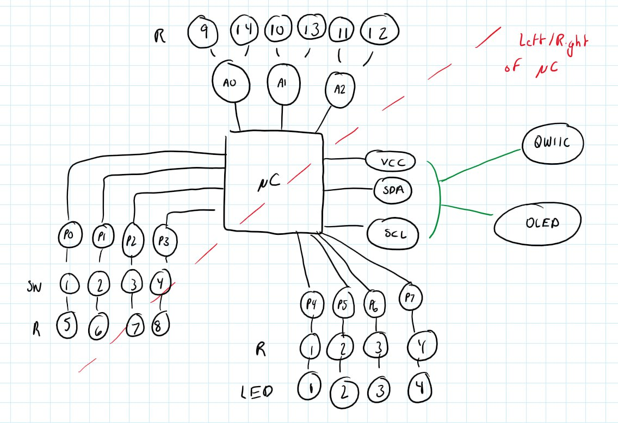

Using this sketch, I laid out the components in a manner that allowed them to cross the least number of other components to reach all their connections. The dotted red line in the image above helped to guide me on where components should be placed so that they would cross sides on the microcontroller as little as possible as that was the component with the most routes leaving and entering it. Once this was complete, I used the auto-route button to get an initial routing plan and then adjusted wires where need be. Once this was complete, I grabbed a Pac-Man image off the web and labeled my PCB as done in imperial units and signed it with my name. This resulted in the following 3D view of my PCB.

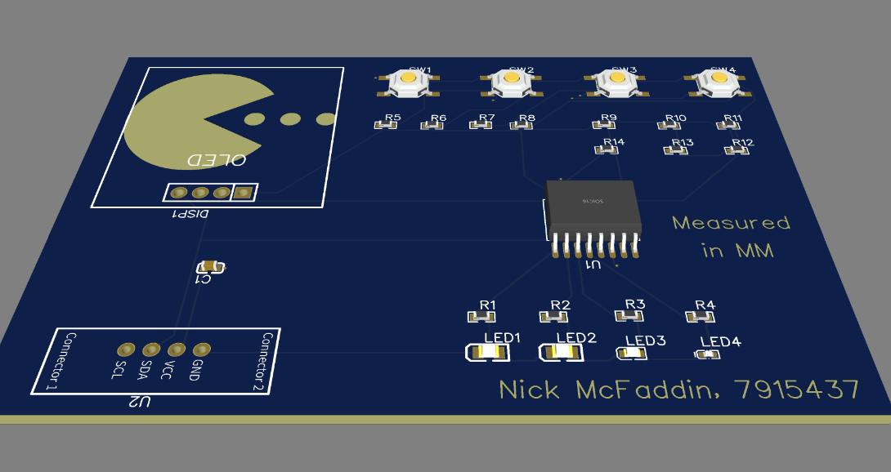

The last task was to edit the BOM file. I spoke with classmate Alex Haigh, and he recommended looking up all the products on Digikey. Another classmate Kameron Ronald suggested that once I had the parts from Digikey, to manually enter those details where relevant in the BOM which would avoid having to do it all on the EasyEDA application. Once this complete, I was left with a nice-looking table as shown in the image below.

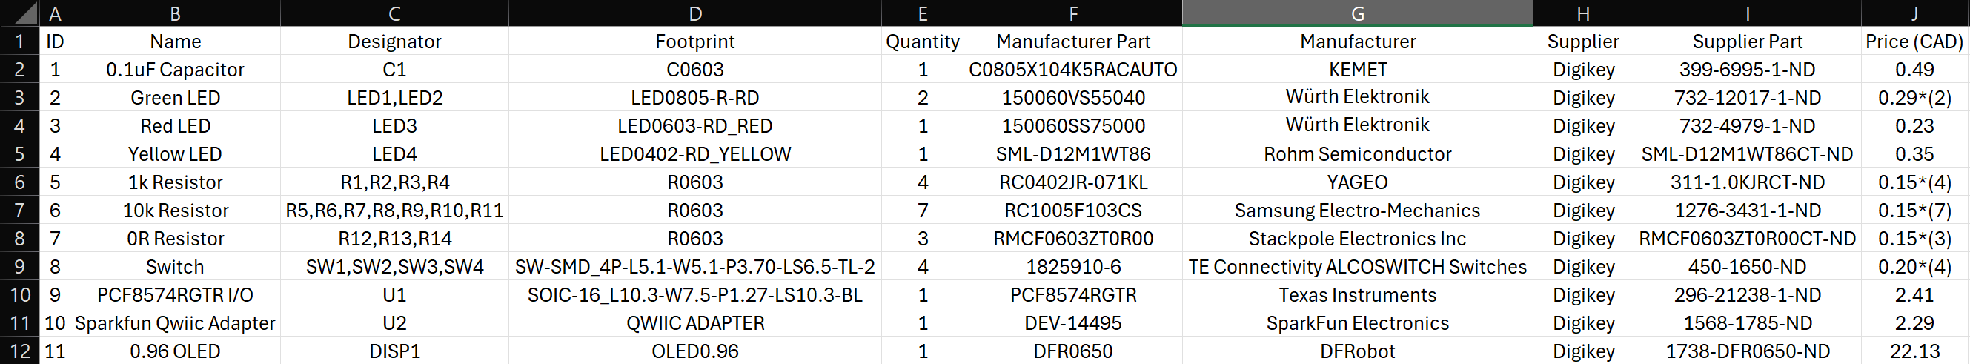

Lastly, I got the Gerber folder and compiled all my deliverables in a zipped folder to prepare for submission.

Note: This was later edited to have unit price, line price and a total price in the BOM file.

**Design Entry 17: February 28, 2024**

In anticipation that today’s lecture would be on the topic of message sequence chart’s, I reviewed our team’s communication protocol and browsed online to see if there were any improvements that could be made. Earlier on this week, my group member Sahej mentioned some details about MQTT as a communication protocol we could look into. Upon some research, I found out the following.

MQTT stands for Message Queueing Telemetry Transport and is a publish-subscribe based messaging protocol that works on top of the TCP/IP protocol. One or more “publishers” (client that chooses to publish messages to outer world) publish messages to a server that can be located anywhere, even local host. Then the server publishes the message to the “subscribers” (client that chooses to receive messages) that have subscribed to the topic specified by the publishers.

Although it was a good thought, having the requirement of a server to broadcast to all of our listeners seems like overkill and out of scope. Thus, I wrote off the idea for the time being but in case of emergency it may be something to revisit.

Today our group met after class to work on power optimization techniques that we could apply to our working prototype. During class, we had a lecture from Bob on message sequence charts. After class, I talked to him about our prototype. Overall, he seemed impressed with the design that we had come up with but had one core suggestion. He mentioned that sweepers are either sweeping hard, lightly cleaning the ice, or doing nothing. Considering this knowledge, we talked about removing the yellow colour on our LEDs that currently indicates moderate sweeping. When bringing this information to my group, they concurred and thus we agreed to remove the moderate function on the analog joystick and instead to have a dead zone in the middle of our joystick.

Transitioning over to our power optimization work period, we wanted to establish an initial baseline for our working prototype. There was one flaw that Kameron pointed out early on that would greatly impact the results of our baseline testing. That was the fact that when a button is held down, we only transmit that signal once and then we wait for another button press. This could be a problem in a case where the skip holds down the left or right button while shifting the joystick around to transmit commands solely for that sweeper, but because of our protocol, only their first command is transmitted, and the rest are dropped.

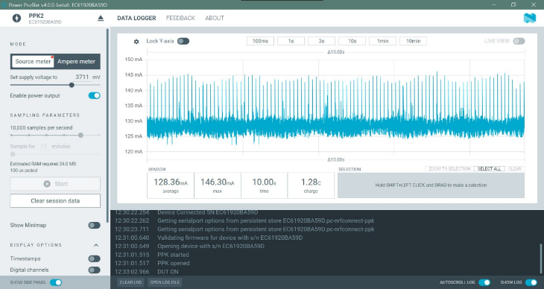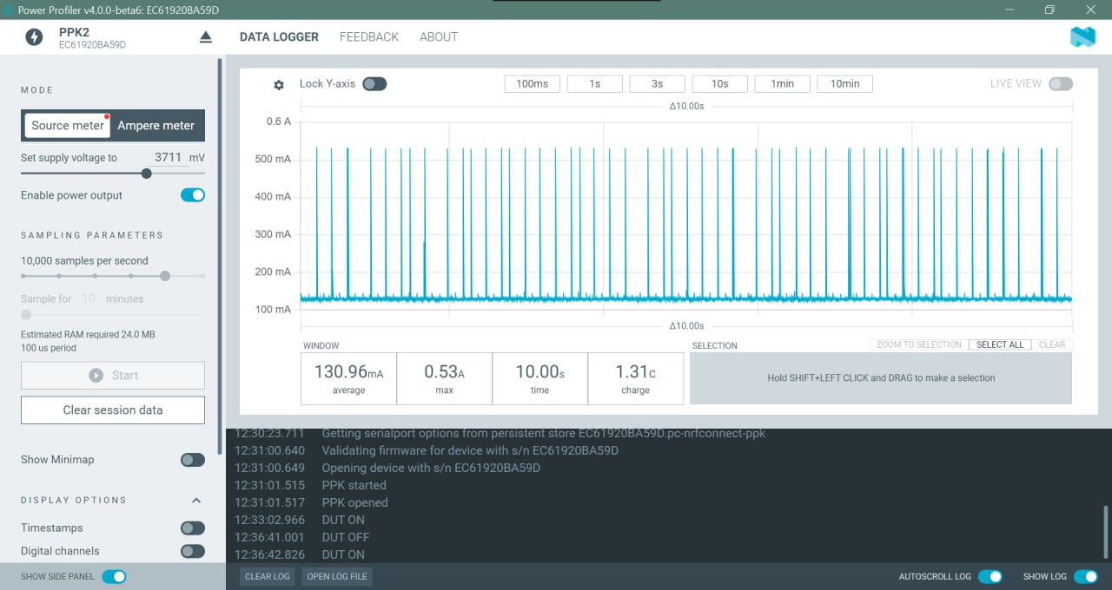

The images above show the power consumption of our transmitter both from a joystick resting position (no transmissions) and a rapidly moving joystick (constant transmissions) on the left and right respectively. This baseline is skewed as our power consumption will be higher once we implement a more frequent sampling protocol, however this is a good starting point.

Later on in the evening, we ended up implementing a protocol much like the lab, that samples the ADC inputs with the buttons every 100ms and uses an esp_light_sleep() function to save power while we are between samples. This will without a doubt use more power than our previous implementation, but it will be a stronger and more effective protocol. We will work more on Friday to get a baseline measurement and decrease the power usage of our transmitter now that these initial changes have been made.

**Design Entry 18: March 2, 2024**

With our baseline and estimations done for our prototype, we now have a goal in mind for where we want to get to for power consumption. In terms of our LEDs, we have figured out that we can save power by only using one of red, green, or blue emission as they each work independent of each other. Using only one of the three cuts our power usage from the max into one third of that.

Our theoretical power usage of our transmitter is lower than that of our receiver currently so to get them to be more similar, we may have to work harder to employ more power optimization techniques on the receiver. This may include synchronization to try to minimize the on time of the receiver which would put both of our devices around the same usage.

**Design Entry 19: March 8, 2024**

Today our group met up to talk about Design Review 2. For this presentation, there are not currently any requirements for the presentation besides the fact that it must be under 7 minutes. Before meeting up with my group, my thoughts were that we should use most of our time to do a live demonstration of our working breadboard prototype and then use whatever leftover time to go over extra statistics like power consumption and next steps.

When meeting up with our group, most others suggested we start with our statecharts or UI design before demoing our prototype. We ended up deciding to go with this flow which I think is a good idea as it gives us a chance to explain our UI design and the flow of how our commands work so that the audience knows roughly what to expect when we start our demonstration.

We decided on Sahej doing the initial UI and statechart explanations followed by Kameron doing a live demonstration. Lastly, I would take the remaining time to go over our power consumption baselines and our group’s next steps which include power optimization, modifying our UI and making a 3D model.

For our power optimization solutions, my initial thought is to just summarize what we did in the lab for the skip and say that we will do something similar to that for our prototype to reach our projections. I am conflicted on what to do for the sweeper as we hadn’t gone over that too much. My first thought is to talk about synchronization so that we are only utilizing the time the sender is transmitting and not having a lot of wasted “on time”. I will follow up with my group members on this as well as possible methods on how this could be implemented so that we are prepared to answer questions regarding this subject.

Kameron started making a 3D model the other day but said that the corners were sticking too much, and he couldn’t get a good print going. Someone recommended to him that his nozzle height might be off which could be affecting the print. We talked about meeting up Tuesday at my house since I have a mini 3D printer at home that we think we can use to do the skip device. I haven’t successfully used the printer before so we are going to debug and figure out how it works exactly which I am honestly excited about since then I can use it for other things too. He is trying to redo the sweeper device at school which would be pretty cool if we could get a model ready to go and to show off at the design review.

In terms of our modified UI, it is shown in the image below. As we were talking, we devised a new, more intuitive UI that would optimize response time and make things easier for the skip to give useful commands. It works with solely an analog stick that utilizes 6 positions on an analog stick to signify which sweeper is sweeping and with what force. In the middle resting position will signify neither sweeper sweeping and a click down on the analog stick will indicate power off and on. I think that this is a great implementation and may even help our performance metrics including power consumption and response time.

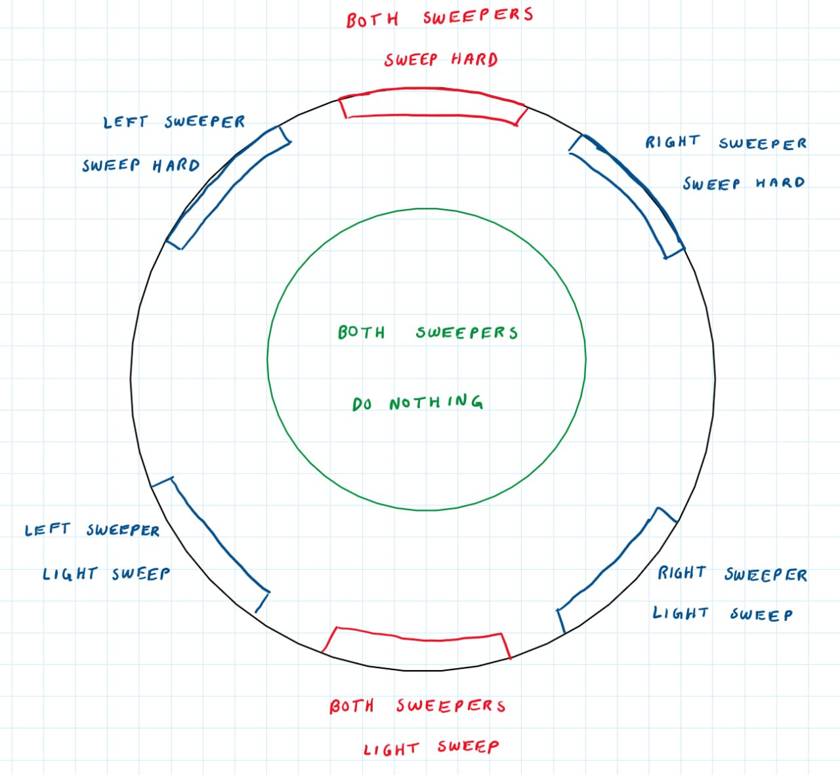

**Design Entry 20: March 9, 2024**

Now I don’t think I will have to present on Monday as our group is the last one to go in the order, but in case we must, I wanted to be prepared to do so. I practiced my slides today after Sahej and Kameron gave me rough estimates of 2.5 minutes and 2 minutes regarding how long their parts would take respectively. This means I will have approximately 1.5 to 2 minutes to finish my part of the presentation.

The other day, Kameron finished making the sweeper device 3D model. Honestly is cool to see what we have been working on come to life into a physical product. The following image is our 3D model for the sweeper device which is a replica of the diagrams that we have been making.

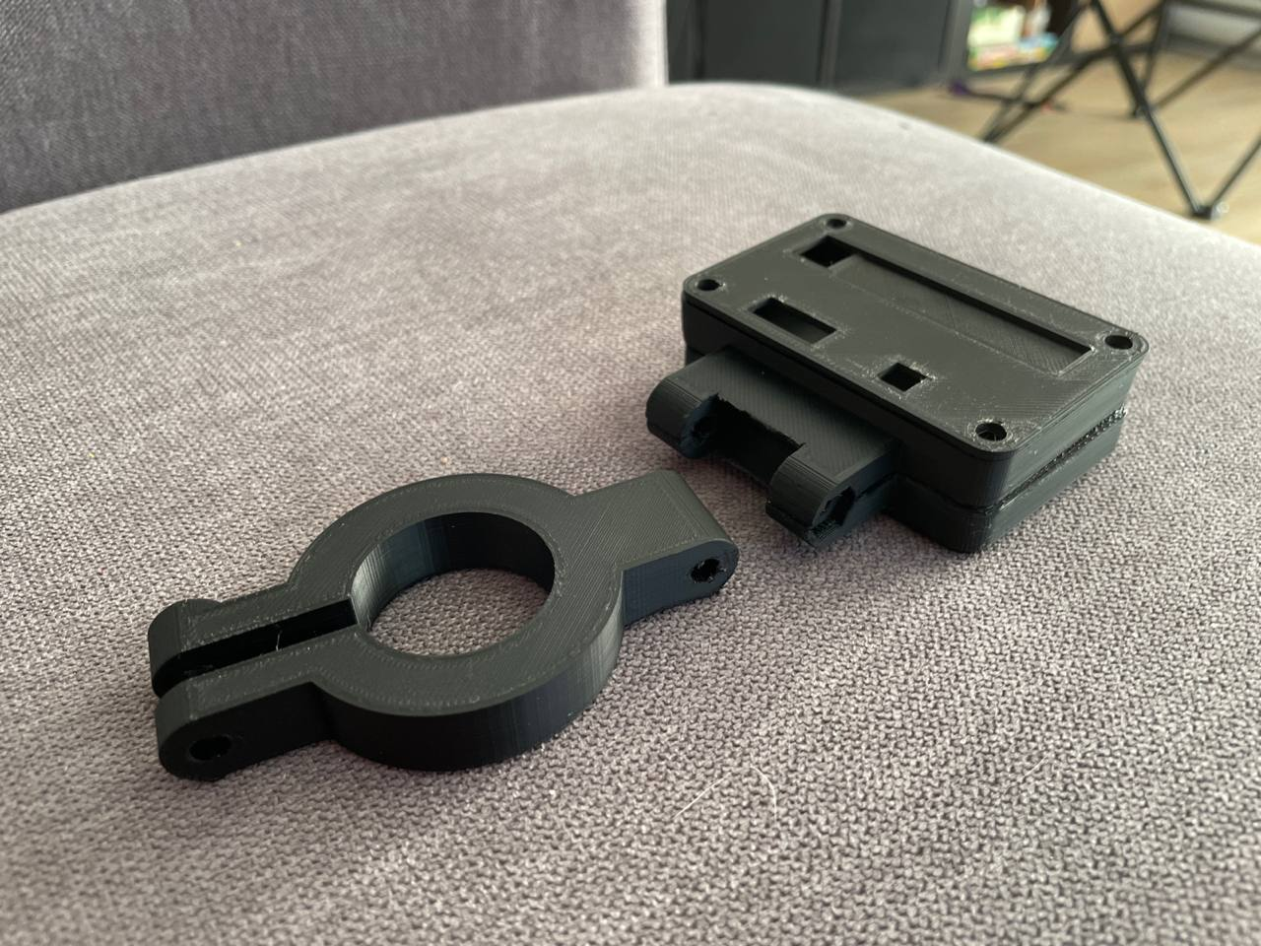

We will use a bolt/screw to fasten both sections of the casing to the broom. The part attached to our LED display is rotatable so that the sweeper can decide how much angle they want on their device. Once this clamps on, our ESP32 and PCB’s will sit inside the casing and our sweeper indicator switch, LEDs and power button will be the only things that are being shown.

We have a version of the skip device model built which Kameron led. It may end up needing a couple modifications but that will be what we are printing on my printer on Tuesday. The blueprint is below.

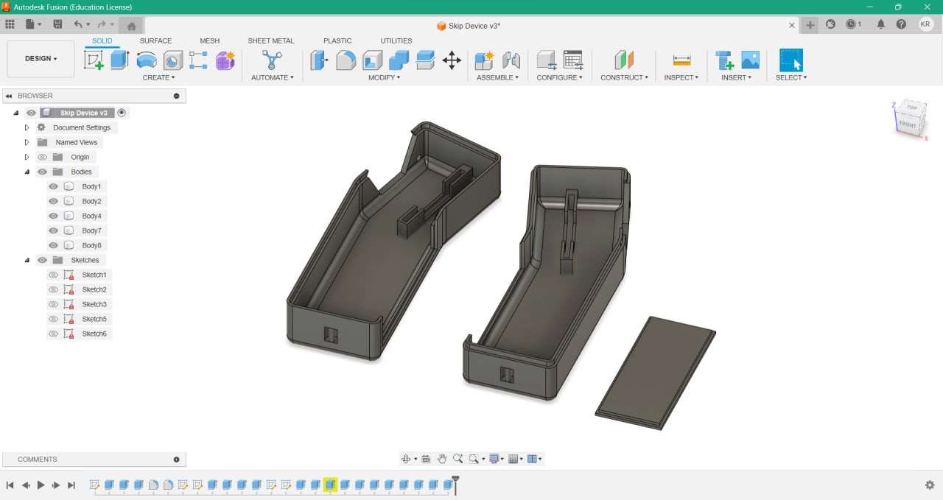

**Design Entry 21: March 11, 2024**

Today I practiced my part of the presentation for design review 2. In going over my slides, there were some key points I wanted to make sure I conveyed to the class.

* Overview of the next steps for the group.
* Power consumption baselines and how we plan to improve.
  + Skip:
    - Baseline: ~140mA
    - Goal: Below 60mA = 10 hours
    - Once we can keep our clock on for PWM and turn everything else off for light sleep, as well as implement deep sleep, we should hit our goal.
  + Sweeper
    - Baseline: ~120mA
    - Goal: Below 75mA = 8 hours
    - Synchronization
  + Looking into using ULP for both the skip and sweeper for significant power savings.
* Redesigning our skip UI.
  + Remove our buttons that indicate which sweeper we are talking to
  + Do everything via analog joystick.
    - 6 positions
    - Right side targets right sweeper.
    - Left side targets left sweeper.
    - Middle targets both sweepers.
* Showing our 3D models.

These will be the points I will try to get out and focus on for our group’s presentation that I anticipate will be Wednesday.

**Design Entry 22: March 12, 2024**

Today Kameron and I met up at my house to work on printing on my 3D printer, the Da Vinci Mini w+. First, we worked on just printing a simple washer which we were able to do fairly easily. While these prints were occurring, we worked on making some modifications to our existing skip device. There were 3 modifications we wanted to make.

1. Make the LED hole sizes bigger as they were 2x too small in the first build.
2. Experiment with a round frame on the analog joystick casing rather than a hexagonal shape.
3. Modify the removeable battery case to be at the end of the case and have a sliding function rather than have it sit in the middle of the back portion of our case.

After this, we tried to immediately print our skip device, but the printer was no longer printing out any filament. We found out that the filament was too hot because of a heater we had put beside the printer which was causing it to expand and get stuck in the tubing. Since the room still needed to be hot, we moved the heater to the ground to keep the room warm but not directly heat the filament. After a long period of attempting to dislodge the filament from the feeding tube, we did it and we were ready to print the skip device. Kameron had to leave so I started the print and then came back after a couple hours. When I came back, part of the print was finished but it looked like part of the build fell off and the printer kept trying to print. I thought it may have been a fluke case, so I tried it again, but the same thing happened.

Thinking about it after the fact, I think I will have to try with new masking tape on the print bed as well as some glue on top of that and maybe adding in a raft will help the prints stick to the bed better.

**Design Entry 23: March 13, 2024**

Today we had our design review 2 presentation. We were able to give a review of our UI for both skip and sweeper, demo our product, talk about our next steps and show off some 3D prototypes (pictured below). In watching other groups, I thought our group’s articulation and overall crowd engagement was done very well. I was happy with how I presented and thought overall that was as good as it was going to get. Bob gave us feedback regarding our new UI design for the skip and said that he thought that was a good idea to use just the joystick to simplify the communication protocol. As well as that, we are going to switch the red and blue LED emissions so that the red signifies “do nothing” and the blue signifies a “clear/light sweep” per Bob’s feedback.

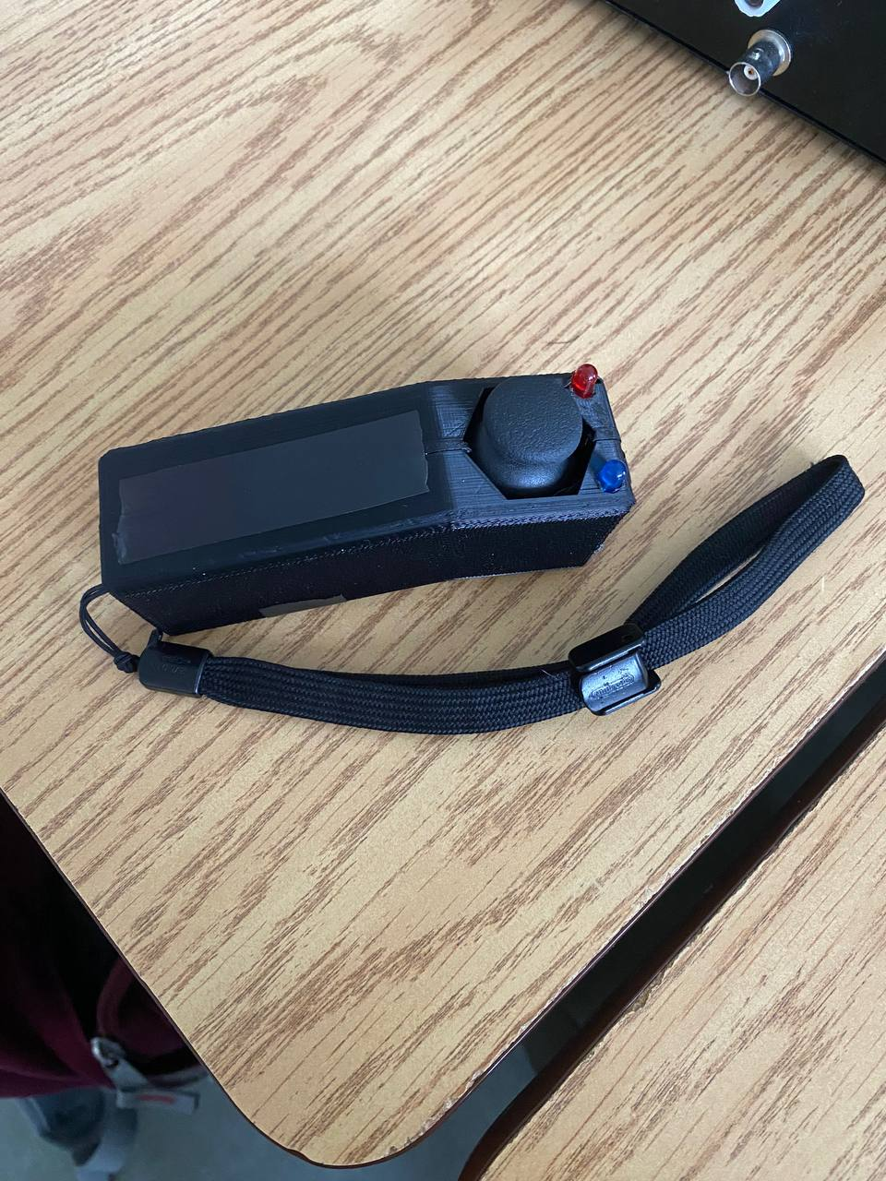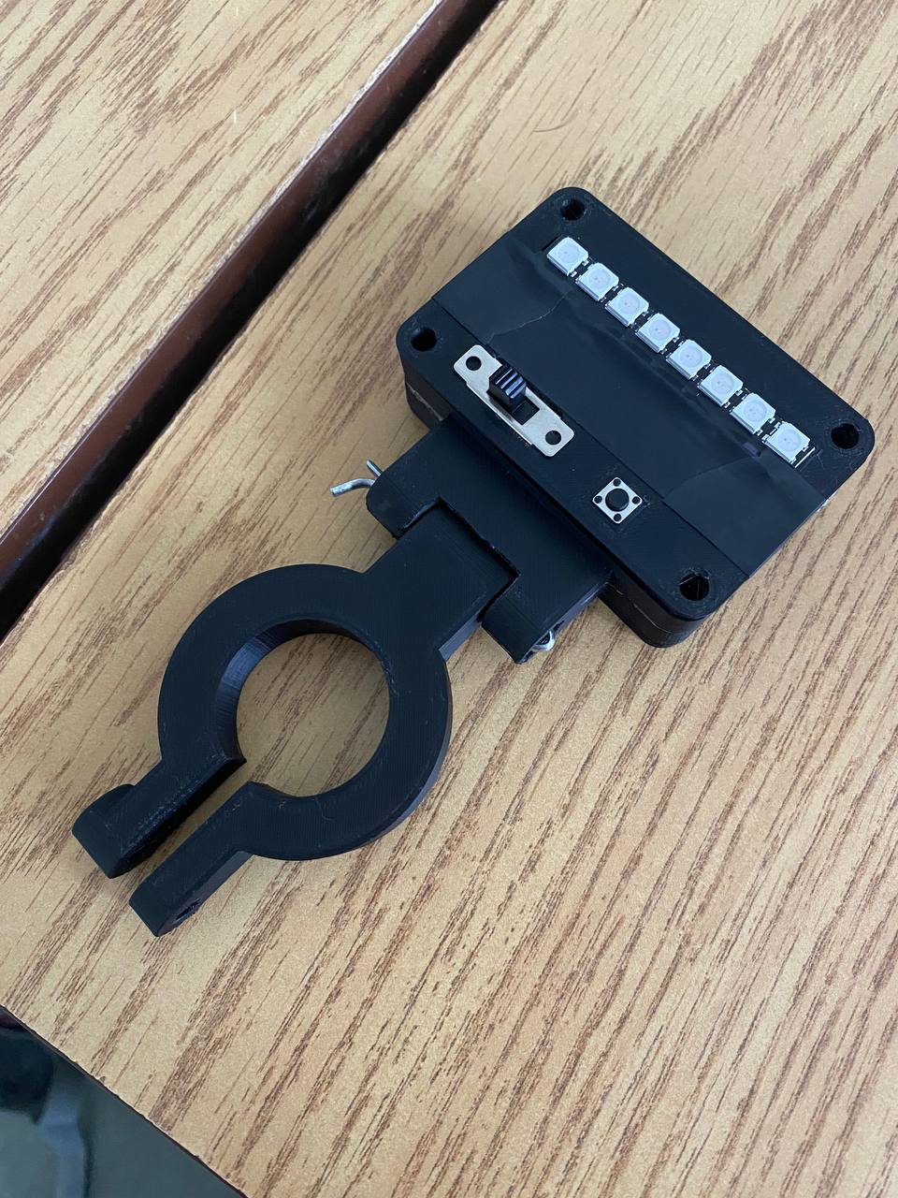

**Design Entry 23: March 14, 2024**

I tried printing our 3D model of the device with a raft but did not have much success. Pictured on the next page were how the prints turned out for the skip device (left is without a raft, right was with a raft). I think next time, I will have to replace the masking tape, and add some glue on top of doing the raft as part of the corners of the build were visibly coming off the side. Quite discouraging but I feel good that there are still things I can try to make the print work properly.

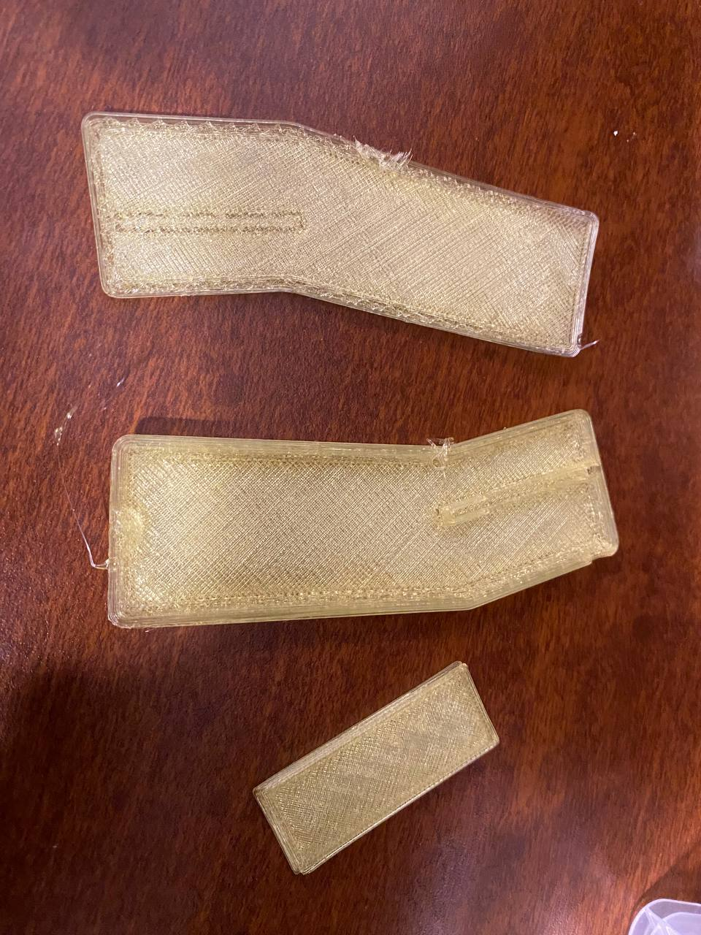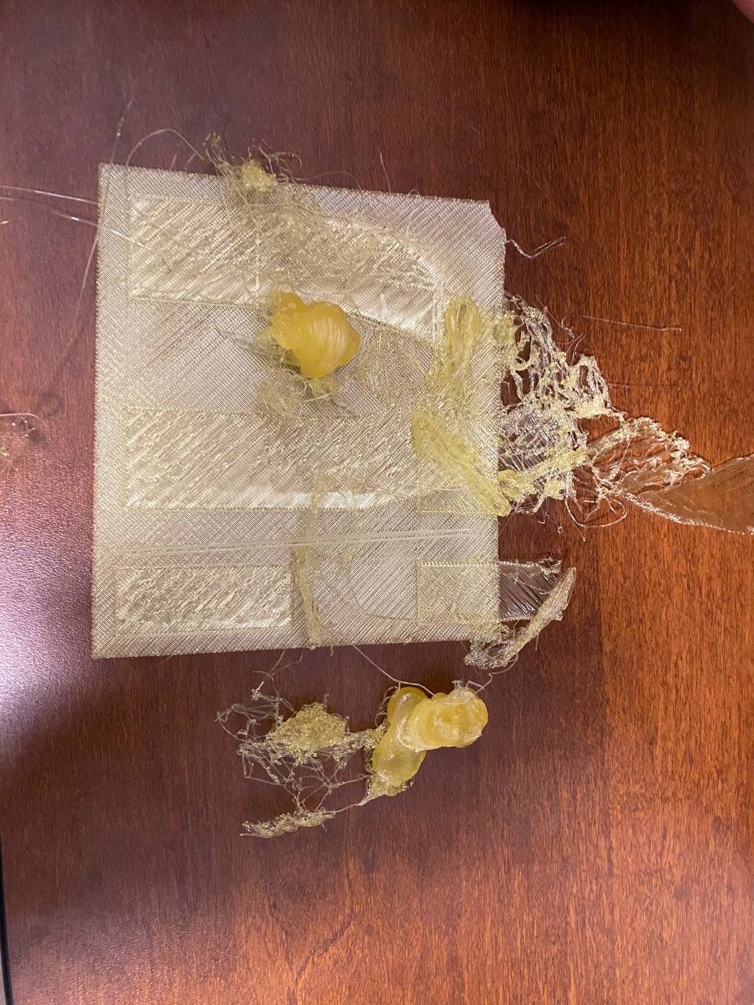

**Design Entry 24: March 15, 2024**

Today, Jillian, Kameron and I met up to create new versions of our prototype for our skip and sweeper devices that would have actual function rather than just being a model. To begin, we outlined what we would need to do to make this happen.

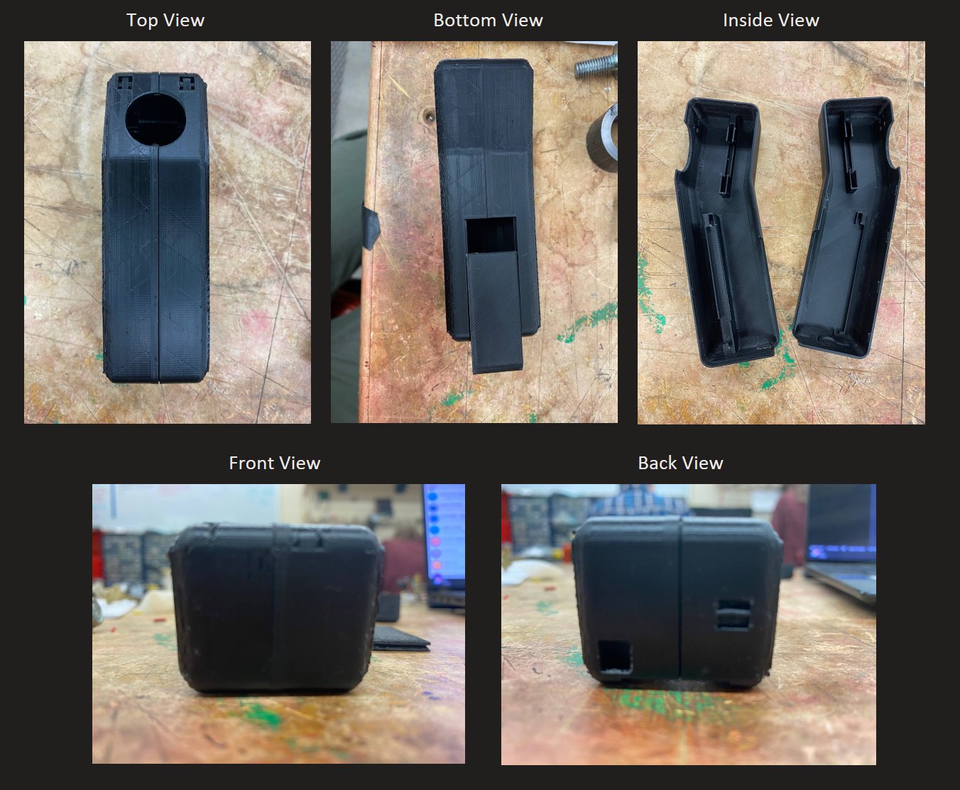

For our skip device, we revised the 3D model to include a slot to insert the ESP32 so that it holds the board in place while in the casing. As well as this, we changed our LED slots to be squares to fit the Neopixel individual LEDs rather than the common anode RGB LEDs. We also added a button at the back that would be for a pairing mode. The new 3D print is shown on the page above.

To start our modifications, Jillian soldered wires onto the individual Neopixel LEDs so that we could attach them via jumper cables to the ESP32 board. I worked on drilling holes through the top of the 3D print to create openings big enough for the LEDs to peek through since the print we made was intended for the LEDs to sit on top with wires peeking through, not for it to have an entire base that would need to come through the back. Kameron worked on using heat shrink to create common power and common ground ports that all our components would connect to. Once these modifications were complete, we started to hook up our jumper cables to the board and joystick. We found that the jumper cables attached to the joystick created problems in fitting our ESP32 board properly. We used pliers and bent the jumper cables which gave us just enough room to stuff our ESP32 in there with all the jumper cables attached. It was very difficult to stuff all the wires in the casing but eventually I was able to do it. I had to put the heat shrink on top of the board so that all those connections didn’t interfere with our wiring on the bottom. Using the steps of attaching the joystick, ESP32, button and then the loose cables respectively gave us the best chance for success. The connected version is shown below.

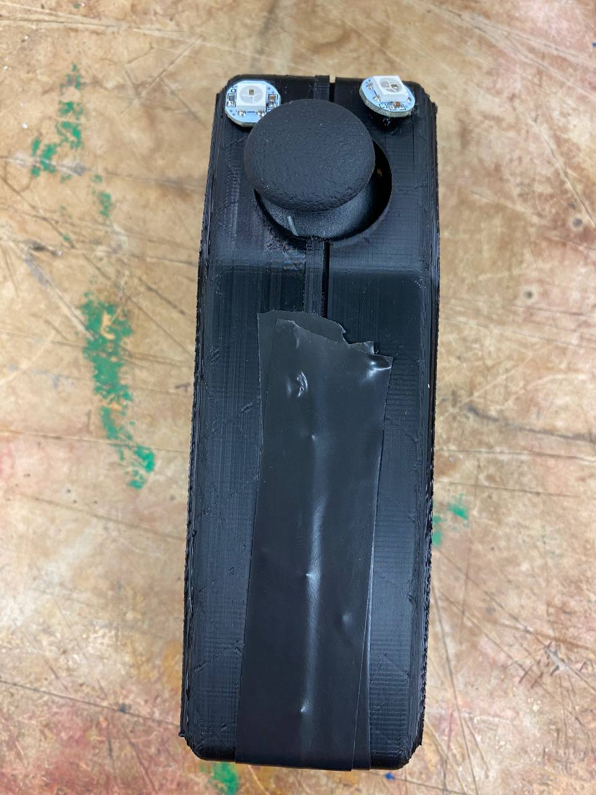

Next, Kameron and I worked on connecting the individual Neopixel LEDs with our new code. We were using functions from the pixels() main function to direct LEFT or RIGHT LED. We realized this was causing us problems and that we instead needed to set the pin to be left or right and use a generic pixels.show() and pixels.clear() function to execute commands. Once we fixed this we were getting the LEDs to light up, but they were blinking, thus we moved our pixels.clear() into the loop which fixed this problem. Our last issue that we were not able to fix is that the left command and both commands are directed towards both LEDs and that the right command has no function. This will need to be cleaned up and then from there we should be done all of our code modifications (barring changes regarding power consumption and performance enhancement).

I made a list of the future considerations we have for the skip device to end off the work day.

1. How we want casing to stay attached (clips, electrical tape, glue, etc.).
2. How we want to keep the individual Neopixel LEDs attached (hot glue, sticky tac, etc).
3. Adding in a spot on the casing for a micro-USB cable to be connected so that we don’t have to disassemble our product to modify the code on the board.

These 3 considerations will be the next things I focus on, as well as revising the 3D print to include that micro-USB port and then making the individual LED holes bigger so that we don’t have to drill them the next time around. Having done this, this will be the design I hand in at the end of the month for our prototyping assignment. Although we didn’t complete our initial goal of having finished models for the skip and sweeper device, we made really good progress.

**Design Entry 25: March 17, 2024**

I brought the box with all our components home the other day, and today I tried to work on fixing the individual Neopixel LED functionality. It turns out that on transportation, some of the soldering had pulled the pins off the button which made it useless, and with our device stuck in pairing mode this was a big issue as I couldn’t get to the actual functionality of our skip device. We will have to think about this going forward, making sure that the supports on our button are strong enough and durable so that no malfunction like this can occur.

**Design Entry 26: March 18, 2024**

Today our group met up to fix the functionality of the LEDs. With a newly soldered button, we fixed a problem we had with indexing the individual LEDs by removing our setPin() functions and instead declaring both in our initial setup and calling them each their own variables. Once this was done, our individual Neopixel LEDs worked perfectly with our existing code.

Kameron and I then went to the workshop to make some modifications to our prototypes. Kameron worked on soldering wires onto our header-less ESP32 board while I drilled a hole in our skip 3D prototype to allow us to insert our micro-USB cable without having to disassemble the build. This took a couple tries as at first, I only accounted for the port itself, but the cable has a casing that is a bit larger so I needed to make the gap a bit wider.

While Kameron was soldering the pins for our sweeper device prototype, I worked on an update of our 3D prototype. The improvements/modifications I wanted to make for this prototype are.

1. Changing the joystick frame to be a hexagon rather than a circle. This will allow the user to have a feel for when the next position starts without having to look down and confirm.
2. Adding a micro-USB port so we can dynamically modify our code and test. Additionally, we won’t have to drill one manually on future builds.
3. Making the individual LED holes go all the way through rather than have them sit as a padding. This will allow us to stick the LEDs out from underneath the build rather than go over top, making for a cleaner build.

I finished it in about 2 hours, and this was the result. I’m proud of the edits as I am new to 3D printing and think it is pretty cool that I was able to do something like that. Later tonight I will try to get a 3D model printed out on my printer at home.

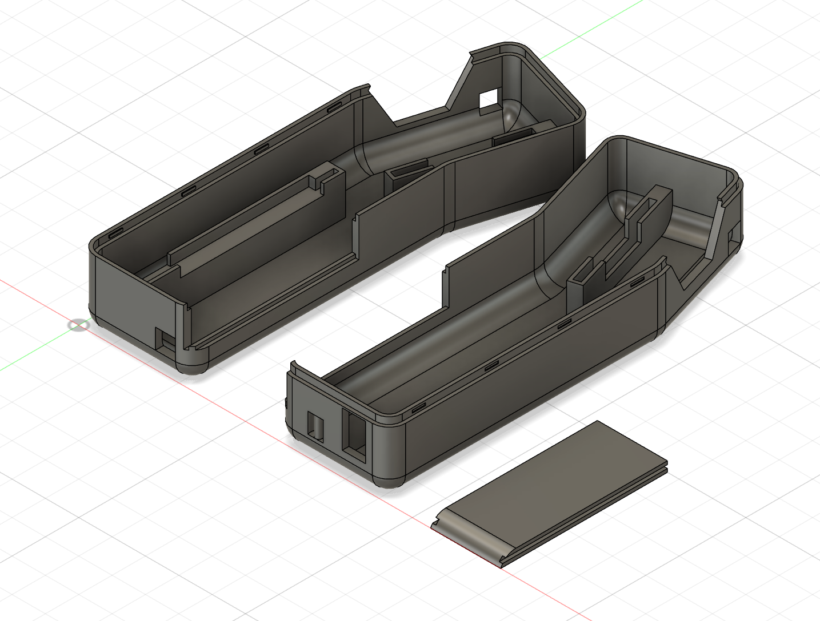

**Design Entry 27: March 22, 2024**

After receiving feedback on Design Review 2, Kameron and I asked Bob a question with regards to his comments about our joystick positions and their associated meanings and LED colours. He commented saying that we should think about how we could further simplify our communication protocol. We talked about how one sweeper light sweeping and the other not doing anything was not a common command and could be avoided altogether. Given this communication, we could shift our 7 commands down to just 5. Pictured below is the updated protocol, and to reflect this, Kameron is changing our hexagonal joystick frame to a diamond. This will allow the skip to give commands in a simpler manner.

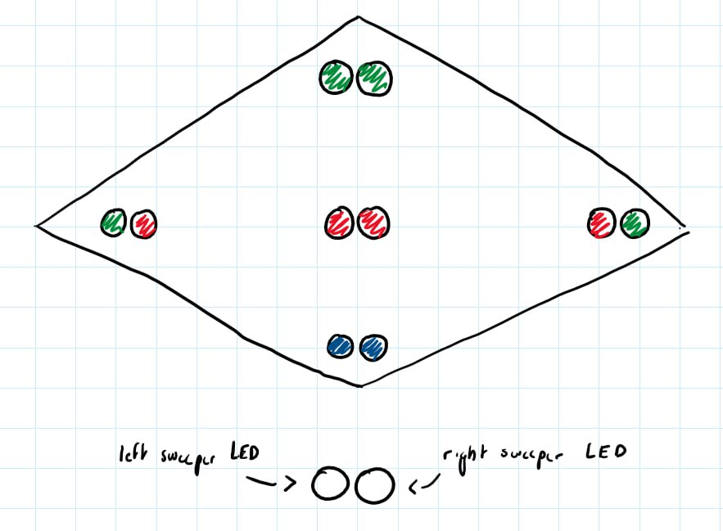

**Design Entry 28: March 29, 2024**

Today I finalized my design for the prototype using the educational license on Autodesk Fusion 360. I had previously worked on the skip device but today I modified the bolt holes on the sweeper device to account for the bolts that we are currently using as they are loose and as a result, affecting the swivel and its associated locking mechanism.

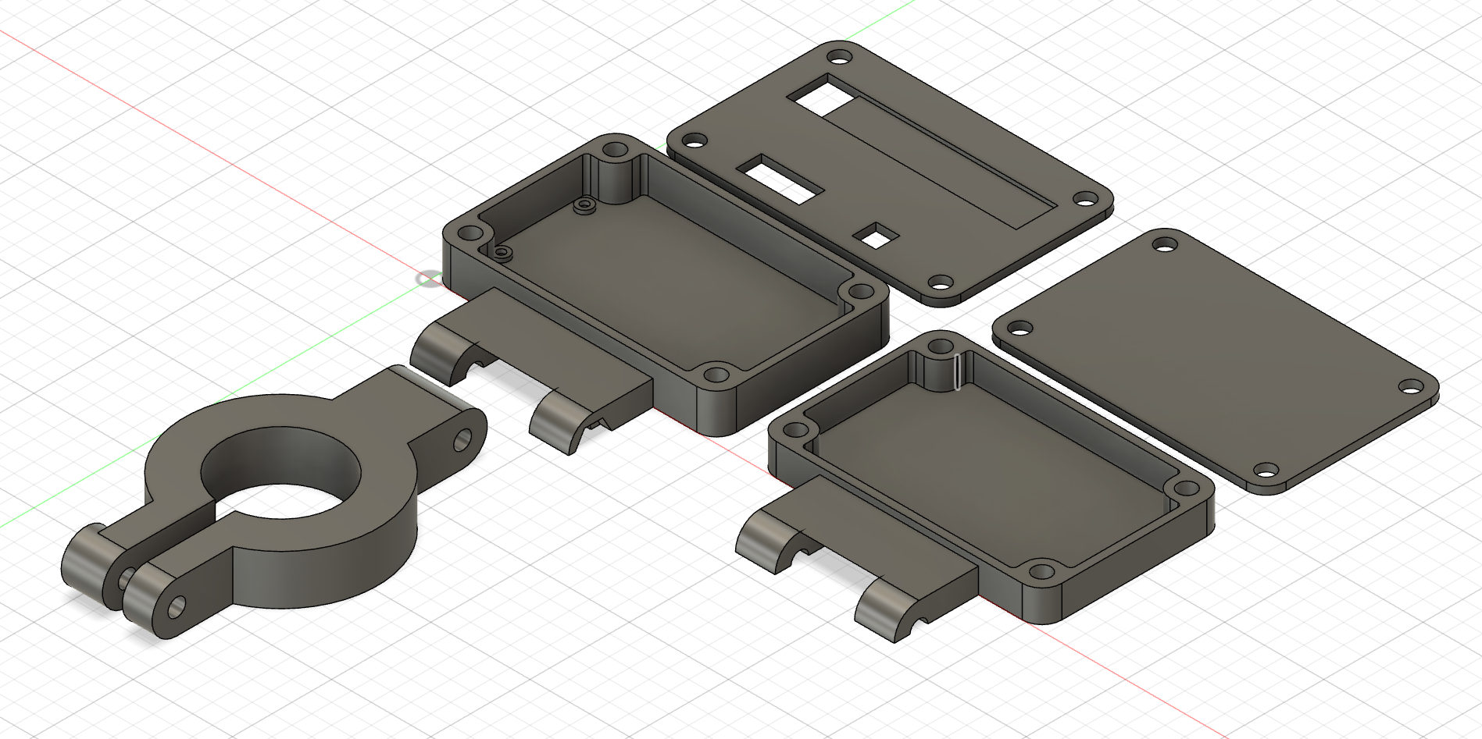

With this, both my device prototypes were finished, and I handed them in along with an associated break down / write up of the prototypes.

**Lab Entries**

**Lab 1 Entry (1): January 22, 2024**

In this lab we learnt to solder for the first time. I watched the tutorial videos beforehand, so most of the tutorial was repeated information. Soldering is using solder wire and a hot iron tip to create a bond between two electronic parts. At first, it was intimidating as I had never had experience with a soldering iron, and I had the tough task of being the first one to attempt it. I started off and the inexperience was very evident. My solder joints were too small, I wasn’t getting enough solder to create a strong bond. As I noticed this, I slowly tried increasing the length of time I was holding the solder wire near the pins. As I did this I got in a rhythm and was able to finish the rest of the solder joints in a much faster and cleaner manner. However, I did end up with a couple icicles (solder joints with jagged edges or solder hanging off the side) and bridges (2 solder joints joined together by excess solder in the middle). To fix these I used the solder iron with a little solder applied to tin the end and the suction pen respectively. Through these techniques I was able to improve my skills as well as learn how to handle the errors I encountered. Throughout the lab, I noticed how warm the environment was and as well as that, how uncomfortable it was to be in that warmer climate with a sweater on. Next time, I would ensure that I am just in a t-shirt and pants as the heat made it more uncomfortable of an environment. Another takeaway from this lab was how important it is to have your magnifying glass positioned properly. Once I dusted off the glass and used my reading glasses instead of the lab glasses, the solder joints I was making were much easier to see and it made a world of a difference.

When I got home, I hooked up my board to the Arduino IDE on my computer. I couldn’t get the ESP-WROOM-32 board to hook up to my computer as it was not appearing in my newly installed Arduino IDE. I watched a YouTube video ([Setting up an ESP32 with Arduino IDE (youtube.com)](https://www.youtube.com/watch?v=CD8VJl27n94)) which immediately cleared up some of my confusion as I didn’t have certain board libraries and drivers installed yet.

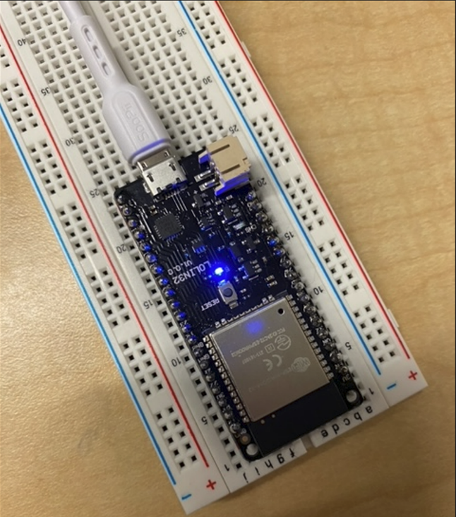Right after installing all the needed software, I hooked my board up to a breadboard to ensure that I did not short circuit it. Then I was able to run the program in the Arduino IDE Installation slides that blinked an LED on the board to verify that the board was working properly. An image of the LED on the board blinking is shown below.

**Lab 2 Entry (2): February 3, 2024**

In preparation for Monday’s lab, I took a look at all of the pre-lab documents that were posted on the course website. The first action item was to figure out the MAC address of my board. The MAC address (media access control address) is a unique identifier assigned to a NIC (network interface controller) for use as a network address in communications within a network segment. Getting the MAC address of our board is the first step to being able to use communication across boards. Through using the code implemented below, I was able to obtain the MAC address of my board which turned out to be 40:22:D8:EE:6D:E0.

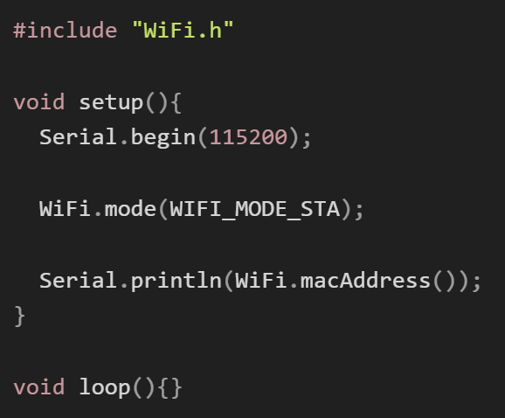

Next was to investigate ESP-NOW, a connectionless Wi-Fi protocol defined by Espressif. This protocol works by encapsulating application data in a vendor-specific action frame and transmitting them from one device to another. Furthermore, the protocol allows multiple devices to communicate without the usage of Wi-Fi. Pairing is only needed on the first connection, following this initial setup no handshaking is required to communicate. The connection is persistent, meaning that if the board loses power, it will automatically connect to its peer and continue communicating. Lastly, ESP-NOW provides various methods of communication. This includes, one way communication, one host to multiple client communication, multiple hosts to one client communication, two-way communication, and a combination of the methods.

Lastly, I researched the concept of a moving average. This term is used to represent a mean of numbers that is constantly changing. For example, if we sampled a value of a number to be 1, 2 and 3 at the first three instances, the average would be 2. Then the next sample recorded a value of 4, then our moving average would consist of 2, 3 and 4 giving us an average of 3. Using this moving average, we would be able to sample the values more accurately in the lab.

**Lab 2 Entry (3), February 5, 2024**

In the first section of today’s lab, we were tasked with reading analog inputs using ADC while incorporating a moving average filter. The ESP32 board has multiple ADC inputs, thus we used an infinite loop to sample 2 ADC inputs, one mapping to the x-value of the analog joystick and one to the y-value. Using our moving average filter, we continuously monitor the average of the newer samples. We used a counter that implemented per iteration of our infinite loop and every 500 iterations, we would send the moving average sample to the serial monitor using Serial.print() to print the x and y values of the analog joystick.

The figure below shows the pin diagram of the ESP32-board as well as that of the analog joystick. Using these pin connections, we were able to carry out the first experiment.

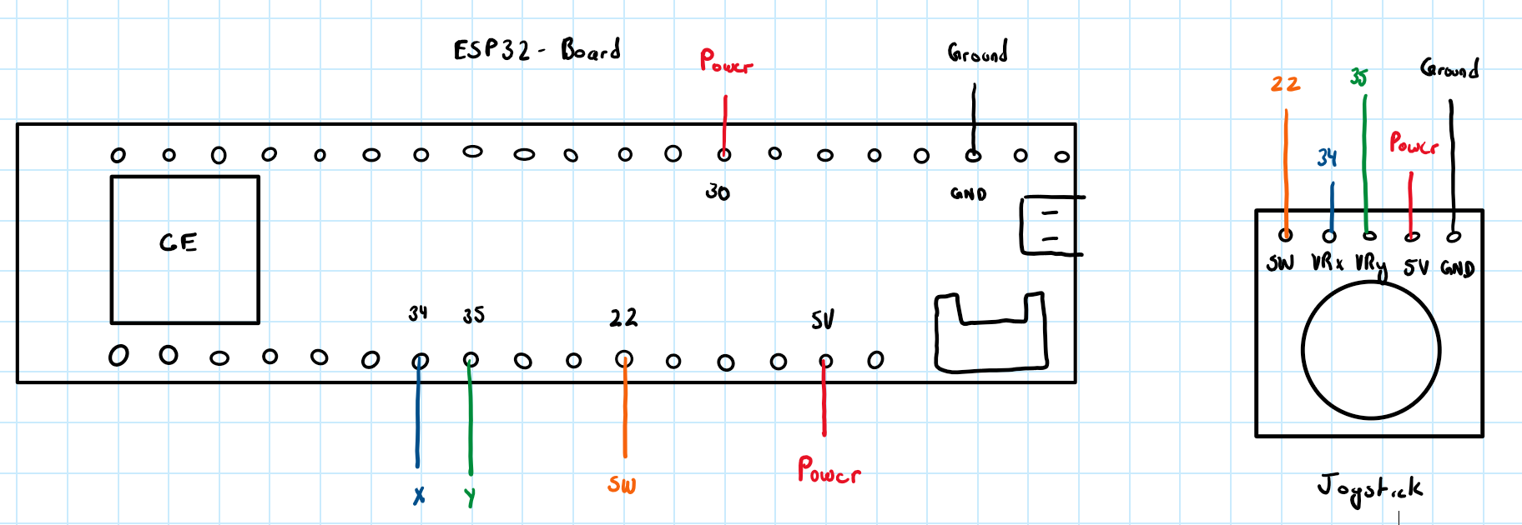

The diagram below displays the x and y values of our analog joystick on a graph.

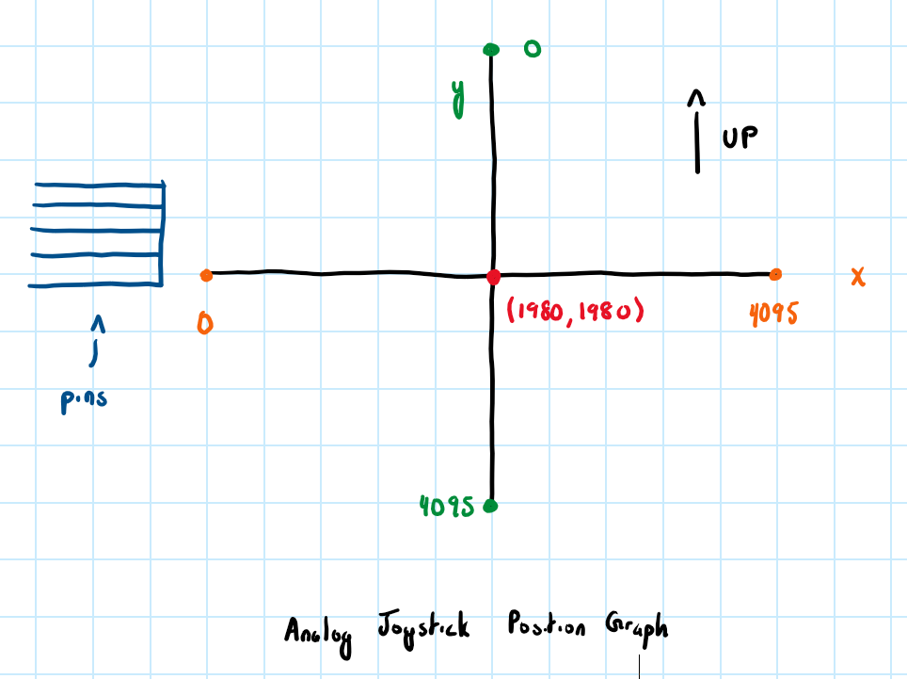

In the second part of the lab, we attached a Neopixel LED to the ESP32 to display the position of the analog joystick on the LEDs. To do this, we installed the Adafruit Neopixel library which facilitated the display. We then mapped the values on the analog joystick to a ring coordinate as shown in the figure below. Since the Neopixel runs on a 12-bit ADC, we had 12 different values (0-11) that corresponded to the different LEDs on the Neopixel We used the ledIndex variable to reflect which LED was being addressed by the analog joystick. Lastly, we used pixels.setPixelColor(ledIndex) and pixels.show() to display the analog position on the LED ring.

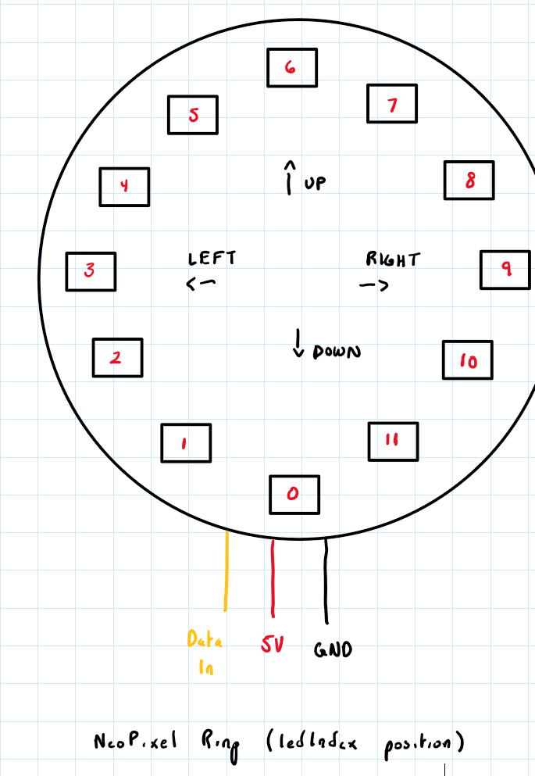

In the last part of the lab, we were tasked with using the ESP-Now communications protocol to use one ESP32 device to send messages to another ESP32. This experiment combines the first two parts. The sender in this scenario uses the first part of the lab to control an analog joystick but instead of just transmitting this information to a serial monitor, it uses ESP-Now to send it in via packets to the receiver. The ESP32 board acting as the receiver uses the code from the second experiment to take the message, decode it and display the analog position from the transmitter ESP32 on the Neopixel ring.

To do this, we had to write new code for the sender and the receiver. Most of the code from the previous parts could be reused for their respective boards, but there were a couple key changes that needed to be made.

Both board implementations needed to include a struct that carried both a gridIndex variable, and a boolValue variable. The boolValue variable is not implemented currently but will be built upon in future experiments. The gridIndex variable displays the position of the analog joystick on a 3x3 grid. This creates a discrepancy as currently our ledIndex variable coordinates with 12 LEDs. Thus, we treat the corner LEDs in our 3x3 grid implementation as 2 LED’s each and the center of the grid as the resting value to allow them to match up. Below is a figure showing the values of the gridIndex that have coordinated to our ledIndex.

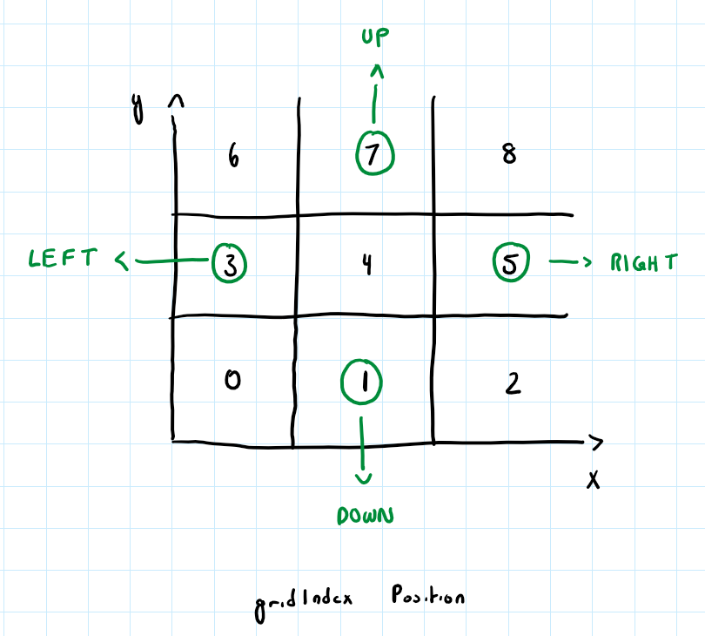

The transmitter board requires the MAC address of the receiver board to perform its transmissions. Firstly, the board carries out the same actions as the first experiment, simply sampling the position of the analog joystick. Then, using ESP-Now’s library, we initialize and use the peerInfo variables, followed by esp_now_send() to send our struct containing the gridIndex to the receiver where it can be decoded.

On the receiver end, once the gridIndex is received via callback function that occurs when the data is received, we map this to the position of the LEDs on the 12-bit ledIndex implementation, mapping to individual LEDs. Theoretically, this should’ve allowed us to display the position of the analog joystick on the Neopixel ring. This worked successfully for the UP, LEFT and DOWN positions, but when we tried to do this for the RIGHT command, we couldn’t get any LEDs to light up.

Upon further investigation, the LED in position 7 was the last one to light up successfully which indicates that there could be a problem with the packets being pre-empted. To elaborate, the packets that are being sent in the further positions are more susceptible to being pre-empted then those that are closer, as they are taking longer to have their information executed before it is being replaced with a new packet.

**Lab 2 Entry (4): February 6, 2024**

Continuing my previous debugging session from the other day, I knew that the problem with my code had to be on the receiver’s end as when checking the serial monitor, I was getting the correct values for my gridIndex variable. After tinkering around, I was able to fix the problem which was that I was using if statements and else if statements which the logic behind it was off and was taking too long for the packets to be processed before they were pre-empted by the next iteration of the loop. I revised this by using a switch case with gridIndex as the variable. This allowed for faster packet processing and for all of the LEDs now to be fully processed before the next packet comes in.

**Lab 3 Entry (1): February 26, 2024**

Today’s lab focused on reducing the power consumption of our transmitter from the previous lab. To begin the lab, we loaded up the same sender/receiver protocol that we used for the previous lab on two ESP32 devices and ran a baseline power consumption test using the Power Profiler Tool from nRF Connect. This tool allows you to use a digital multimeter (DMM) to measure the “Burden Voltage” (voltage across a resistor) using a resistive shunt. We only were performing power reduction techniques on the transmitter as David indicated that he had made previous attempts on the receiver side, but it was very difficult as most of the time we have to be listening for a command from the transmitter. Our initial baseline test from the transmitter is depicted in the image below. This baseline test shows the transmitter’s power consumption when the analog joystick was in a non-center position. The criteria of the lab indicated that the transmitter should always be transmitting when the analog joystick is in a non-center position, whereas in a center position, it only should transmit the first time, and subsequent times it should transmit nothing which would indicate that it is at rest. Thus, our baseline test below shows our “worst case possible” power consumption over a 1-minute interval.

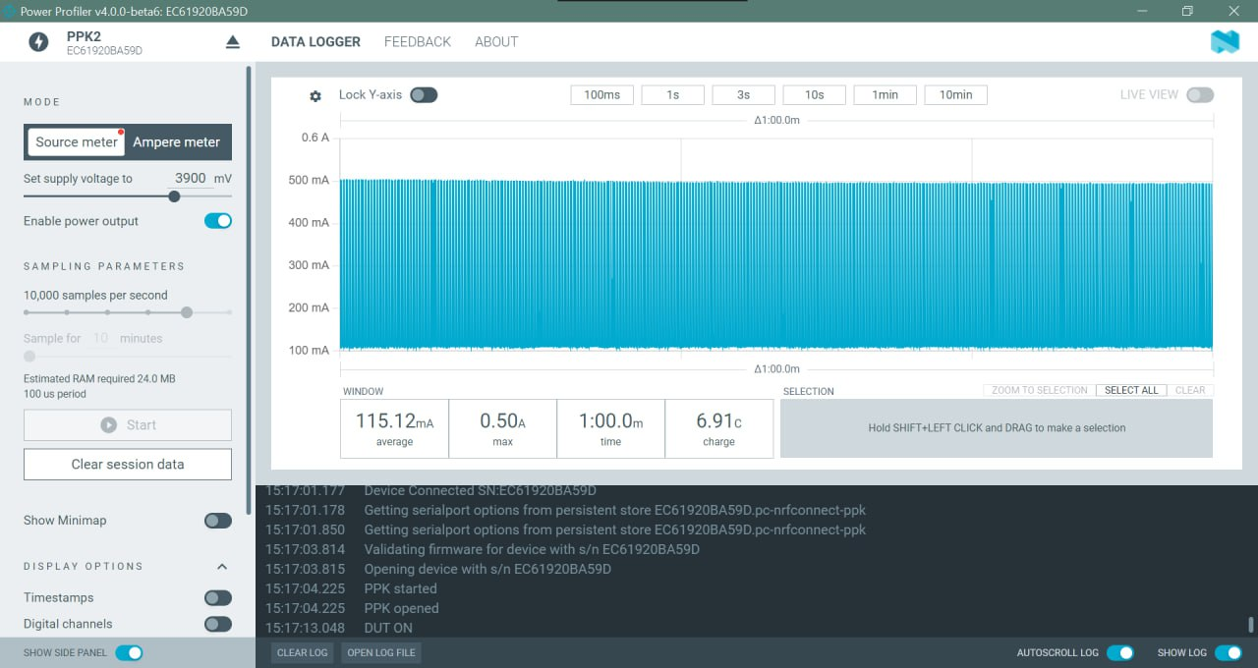

After we had our initial baseline test done, we talked as a group about the suggested power consumption reduction techniques. We decided on going with an event-driven transmission protocol as we felt this would be straightforward to implement, and a good starting point for a topic that we were unfamiliar with. To begin, we defined a “DEBUG” global variable and used it to wrap all the Serial print statements. We then used esp_light_sleep_timer_enable(100*1000) to set the time that our WiFi would sleep for when called to be 100ms (since the function’s parameters are in microseconds). Then we used a sequence of esp_wifi_stop(), esp_light_sleep_start(), esp_wifi_start() to turn the WiFi off, sleep for 100ms and then wake up, turn on the WiFi protocol again and resume our sampling and transmission. All of this was done in our main loop and the power consumption results are shown in the figure below. They were reduced from ~115mA to ~85mA which is a great start as we decreased the consumption by ~30mA.

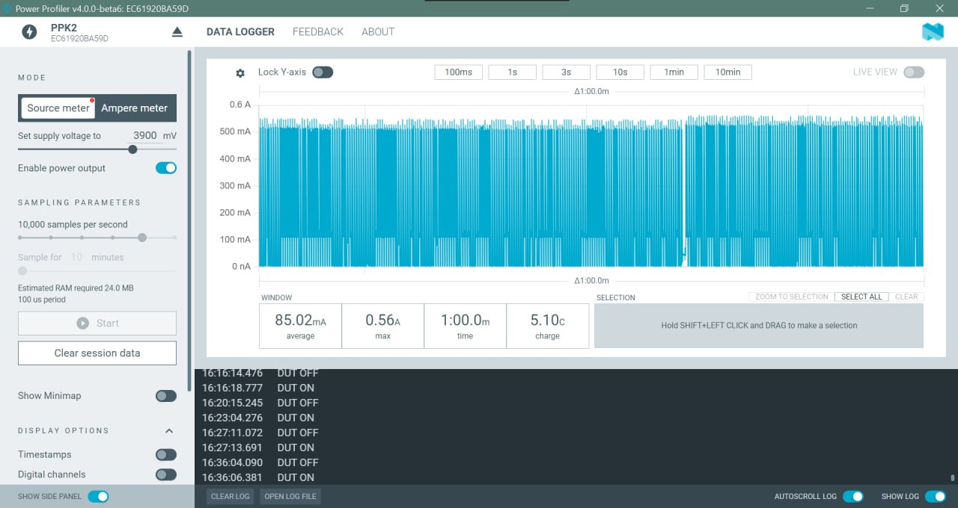

After a chat with David, he mentioned that he did not know why, but using the esp_now_init() function could decrease our power consumption. In addition, he talked about how ESP32 boards use two cores, where ESP-Now including WiFi works on one and general GPIO and other activity works on the other. We used the light sleep function to sleep for 100ms and then used millis() to delay for 20 seconds to allow transmission to occur and ensure that we were receiving an acknowledgement and that our transmission packets were not waiting in queue, but they had actually transmitted fully.

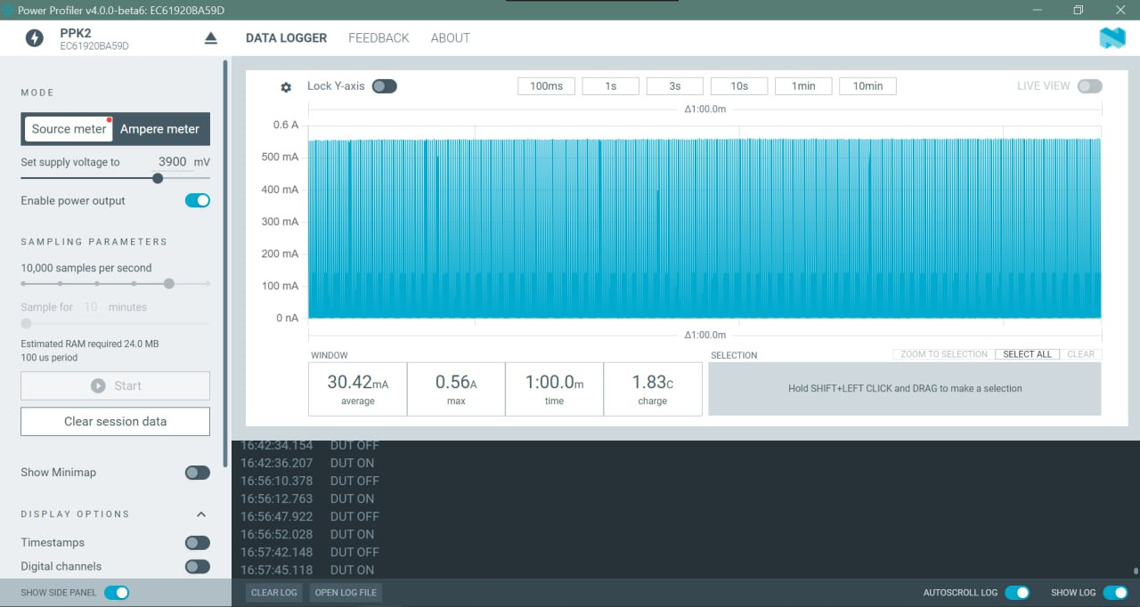

Having implemented this two-core adaptation into our code, we were ready to run our next power consumption test. This time we clocked in at ~30mA as shown in the figure above. One issue that we were experiencing was that at certain points, our program would not be sampling properly and even when the joystick was not centered, it would delay for a considerable amount of time before adjusting to reflect the position. Upon showing our new product to David, he cautioned us against using the millis() function as it would not always reflect the appropriate time when we would be able to sample again. A solution to this was using a callback function with a volatile boolean. To do this, we moved all of our WiFi stop and start, light sleep and esp_now_init() to our callback function and outside of our main loop. On a call to our main loop, we just dealt with GPIO and non-ESP related functions. The main loop would check the position of the analog stick and if it was non-center or not-previously center and currently center, then it would transmit. If it was center position and this was a consecutive appearance as centered, then it would skip and not transmit. On a transmission, we would set our enableSampling Boolean to be false which would only be swapped back to true at the completion of the callback. Using this, our transmitter would know exactly when to transmit and thus create an optimal time frame for transmission and power usage. With this change complete, we were finished implementing the event-driven transmission protocol for the lab. We ran a final power consumption test and were very pleased with the results.

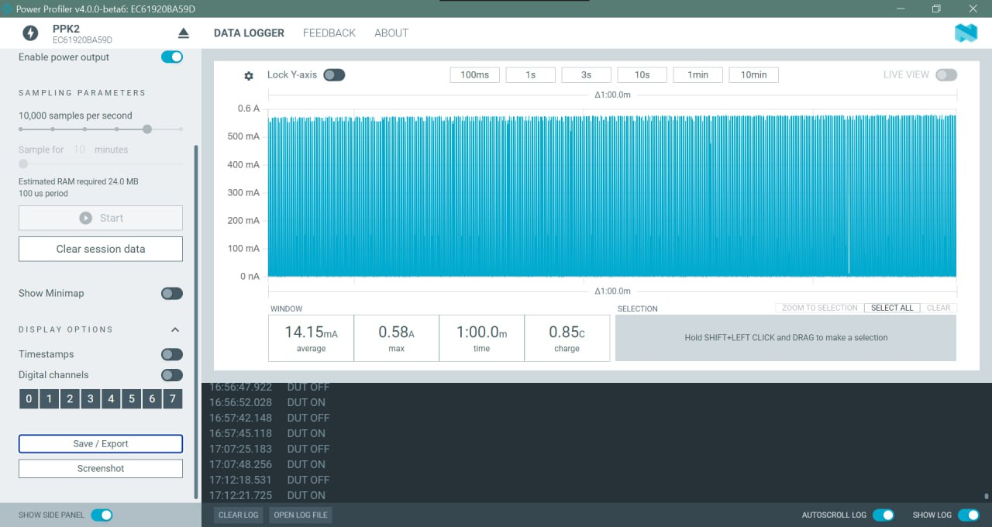

As shown in the figure above, we achieved a result of ~14mA for a minute of sampling at our “worst-case scenario” with the analog stick staying on a “left” position.

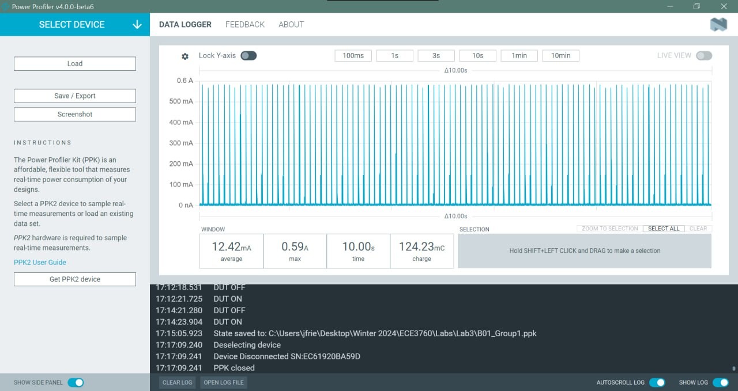

The figure on the page above shows the final product that we submitted which is our power consumption over a 10-second interval accounting for the “worst-case-scenario” again. This measurement was around ~12.5mA which was a huge improvement over our initial ~115mA.

**Lab 3 Entry (2): March 1, 2024**

The limit to the power saving techniques on the receiver device is due to its constant need to be listening for commands from the transmitter. Any type of sleep function that we could employ on the transmitter cannot be reciprocated for the receiver as when the receiver is sleeping, it isn’t listening and if we miss one of the commands given by the transmitter, that could cause fatal errors in our communications protocol. For this reason, nearly all the power optimization work will be done at the transmitter side and the receiver will have only basic optimization done on it so that it can always be listening. Our optimization on this side would be done to limit the amount of current the receiver uses while still allowing it to monitor transmissions from our sender at any time that it has its power on.

If we were to perform more advanced power savings techniques on our receiver, we could use some sort of synchronization to only have our receiver on right when the transmission from the sender is occurring. I would imagine that this would require some sort of common clock between the two and that the transmitter would have to provide the clock for the receiver as well in this case. This would allow both devices to be off for most of the time and only to be turned on and active during transmission periods.

In terms of our prototype, on the transmitter side, we have two RGB LEDs, a joystick, two buttons, some resistors, an 800mAh Li-on battery and our ESP32 board. With the buttons and resistors current values being negligible, we can narrow our current intake down to the work done on the processor, the fixed current from the joystick and the LEDs. Using basic datasheets ([LED](https://cdn.sparkfun.com/datasheets/Components/LED/YSL-R596AR3G4B5C-C10.pdf?_gl=1*dxswj*_ga*MTI2ODg4MTAzLjE3MDkzMTMwMjE.*_ga_T369JS7J9N*MTcwOTMxMzAyMS4xLjAuMTcwOTMxMzAyMS42MC4wLjA.), [joystick](https://components101.com/modules/joystick-module)) we found online, we obtained measurements of 20mA (this is because it uses 20mA respectively for red, green and blue max values, and we only ever use one of these at a time) and 5mA for the current intake of our common anode RGB LED and analog joystick respectively. Having 2 LEDs and using PWM to limit the brightness and power consumption of each individual LED, we can assume our current intake to be 30mA (LEDs + joystick). Assuming we can get our transmitter’s current consumption down to ~30mA, we will have a total power consumption of ~60mA when the power is on. When the power is off, our joystick still consumes its fixed 5mA, but our LED only slightly leaks power at around 1mA, with our processor being off, we can assume only a small leakage in power and thus our power consumption when off should be ~8-10mA. Using a calculation of 800mAh/60mA, we get an expected battery life of approximately 13.33 hours.

On the receiver side, we have an ESP32 device, 8 Neopixel LEDs (WS2812b), a position switch, some resistors, an 800mAh Li-on battery and a power button. With the current intake of the resistors, switch and button being negligible, we can focus on the current intake regarding the processor and the power consumption of the WS2812b LEDs. Considering the LEDs take in a maximum of 30mA when on and 1mA when off, we will have a total of 240mA max power consumption from our LEDs when we are on and transmitting and 8mA when off. The current intake when on can be limited to ~24mA using 10% brightness on our Neopixel LEDs as their power consumption scales linearly with the brightness. On the receiver side, without any power optimization techniques being employed, we would expect ~100mA current intake when the device is on. Adding these together we get an overall of around 124mA for the receiver device. We then take 800mAh/124mA to get an expected battery life of approximately 6.5 hours. I would expect that in doing some power optimization, we could reduce our processor’s current intake to around 50mA which would bring us down to an overall of 74mA and a battery life of 10.8 hours using a similar battery life calculation.

Today our group met again to work on power optimizationfor our prototype, continuing the work we did, referenced in Design Entry 17. We took a baseline for our transmitter and receiver without any power optimization techniques. Below is a figure showing our baseline for our transmitter, which was ~140mA. This scales nicely with what we thought our approximate baseline would be and gave us confidence that through employing similar techniques to the lab that we could bring our transmitter power consumption down to the ~60mA we projected, allowing ~13 hours of on time.

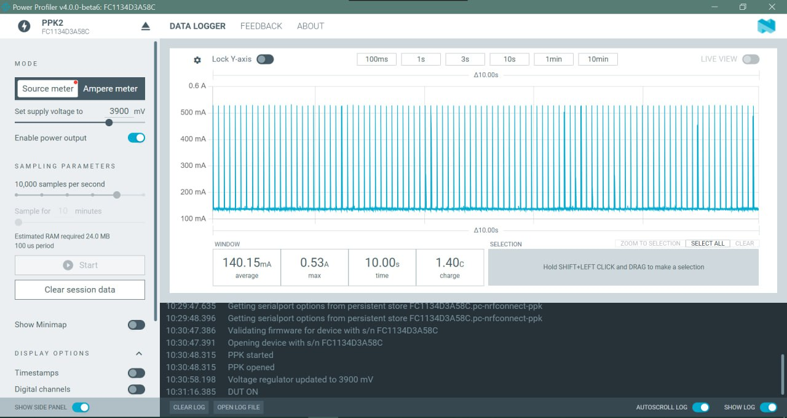

The image below this shows the baseline for our receiver which is ~119mA. This makes our projection of ~74mA very realistic which would allow for a battery life of ~11 hours.

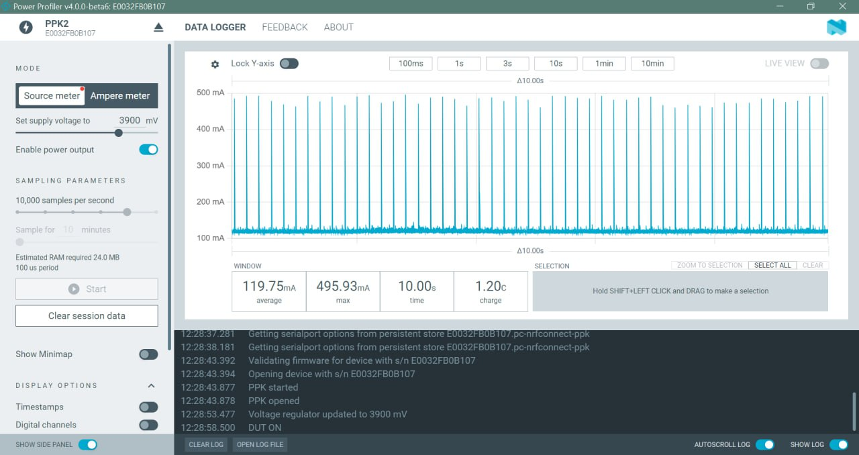

**Lab 4 Entry (1): March 10, 2024**

Today I looked at the lab 4 document. We were given 4 problems and are tasked with solving at least 2 of them.For simplicity’s sake, I wanted to do the debouncing buttons problem as that is one that I already have a mental picture of what I would do. In addition, I think that calibrating the ADC or solving the “unknown MAC address” problems would be cool too.

**Lab 4 Entry (2): March 11, 2024**

I paired up with Kameron from my project group to do this lab. He had already started on two of the problems so those were the ones we decided to work on. We used the working prototype of our project that we had built on breadboards and implemented the problem-solving techniques over top of them.

The first problem we chose to solve was de-bouncing buttons. In this problem, we were tasked with using 2 buttons with a corresponding LED that would respond to each press respectively. A third button would turn both previous two LEDs off. A final LED would indicate a de-bounce period whenever one was active from any of the buttons. To do this, we needed to implement a non-blocking method so that we could toggle LEDs simultaneously even during a de-bounce period.

Our initial setup contained variables for both LEDs and then multiple variables for the button states. For each button, we performed edge detection, the same as we had done for our project, and because of this we held the current state, last state and now the last debounce period which would be stored in milliseconds using the millis() function.

In our setup loop, we configured the buttons as inputs and the LEDs as outputs. In our main loop, we sampled the 3 button inputs and checked for a shift in each button using our debounce function. This function checks for noise, comparing the current state to the previous state and if they are different, starts the debounce timer and resets the last debounce period variable to the current time, setting our debounce Boolean to true. We will then continue to sample the button in our main loop and once we have eventually hit the end of our debounce period, we will modify our debounce Boolean to false and change the button state to the opposite of what it previously was using edge detection. We did this for all 3 LEDs simultaneously and would check if any of the debounce Booleans were true which would indicate that our 3rd LED should be on and end our main loop by updating the states of each LED.

When we ran it initially, the third button worked which would clear the other 2 LEDs colour’s and illuminate the third LED indicating that a debounce was taking place. A problem that we were having was that pressing buttons 1 or 2 was not activating the debounce LED. In looking further at the code, we found that this was because we were sharing one debounce time amongst all the LEDs, thus when one was pressed, the debounce would occur, but we would immediately sample the next button which was not experiencing a debounce and our LED would immediately turn off and remain off. To fix this, we added Booleans for each button that would indicate if it was in a debounce period. Combining this with our previous code, we would loop through and check for one button at a time if they were in a debounce period and if so, would increment that button’s associated debounce timer until it reached our value of 10ms. Once it did, it would exit the debounce period and the LED would remain off. Doing this allowed us to simultaneously press buttons and get dynamic responses that associated with our debounce LED. This completed the de-bounce problem.

Next, we shifted gears to the “unknown MAC” pairing problem for ESP-Now using broadcast packets. This problem focused on pairing a skip and sweeper device without knowing the MAC address of the other. To do this, we would have to validate the packet type before doing anything with it, have 2 modes (pairing and normal) and implement a method that would allow us to clear the peer list once it became full.

To begin, we came up with a validation strategy to validate our packets before performing any actions. We implemented two separate structs, one for data packets and one for pairing packets. The data structs contained a team (would be set by us at the start), a type (pairing or data), an id (skip = 0, or sweeper = anything above 0), and a left and right state (used to signify which sweeper we are talking to). The pairing struct contains an identical team, type and id with a change in the last couple variables as it includes a MAC address and a WiFi channel rather than the left and right states.

We set our max number of peers to be 3 and move to our initial setup loop. In the setup loops we configure our packet structs with preset variables for team and type. Additionally, for the skip device we configure our inputs and for our sweeper, we clear our peer storage struct and add ourselves to the list, while toggling the LEDs to indicate that a connection has been made.

In our main loop, we sample our inputs and then differ to our respective skip and sweeper functions to perform the rest of our logic. In our skip function, we check if there are any connected peers. If there aren’t, we delay and wait until there are. Assuming we have at least one connection, we check if we are communicating with the right or left sweeper using our left and right state variables. Then we check what command has been associated with it and communicate to the correct LED to alter its colour. We also have an additional button, that when pressed, enters us into pairing mode after removing all connected peers.

In terms of our sweeper devices, they will check if they have been paired, and determine which side to listen to via their position switch. They will then turn their LEDs to the colour that was sent over the data packet. If they are not connected, the LEDs will turn white to indicate pairing mode and will repeat this until they get a connection. A push of our power button also sends the sweeper into pairing mode on a reboot. With this all done, we have successfully implemented the solution in our project and will be using it going forward.

**Lab 5 Entry (1): March 25, 2024**

Today we had lab time to work further on our prototypes for both the skip and the sweeper. Our group decided that the majority of today’s work period would be dedicated to refining the skip’s software. We split up into two groups. Kameron and Sahej were working on adding multifunctionality to our button. The end goal of their work would be for a long press of the button to power off and on the device and a double press of the button to enter and exit pairing mode. Jillian and I worked on implementing deep sleep for the skip. After a certain period of inactivity, the device should power itself off and be awakened by any press of the button. This would be the rest of the software implementations that we would have to employ for our device and then we can transition to soldering to our final prototypes and working on the power optimization that is to come along with it.

The first thing that we worked on was adding in an external wakeup reason to our setup function. We set this reason to be the pairing button (GPIO_PIN_22). Following this, we added two variables that would indicate the previous state of the joystick. If there was no change between the previous joystick X and Y variables and their current states for a certain period of time, then we would enter deep sleep, and only wakeup on a press of our pairing button.

The first problem we had was trying to make sure that the position values for the current and past position values of the joystick were identical. Due to the small changes and noise that occurs, they are constantly flickering between slightly different values, thus we had to add a buffer on either side to ensure that we were accounting for this flickering. Now we had a working rest case.

From here we found that the board was going to sleep but we were not able to maintain this sleep case. Upon further investigation, this was because we had enabled two different wakeup reasons. We are using the timer wakeup in our regular loop protocol for the skip which is associated with light sleep and then trying to use the pairing button wakeup condition for waking out of deep sleep. We altered our program to disable the timer wakeup right before performing deep sleep as that case would always occur before even the quickest button press. This allowed for us to enter deep sleep properly. The only problem was that we were not able to wakeup. With David’s help, we found that the problem was that we were using a pin that was not RTC enabled.

Looking ahead to wrapping up our project, these are the action items we have left.

Mandatory Software Updates

* Improve double-press.
* Fix joystick mapping to be 4 positions.
* Update pairing button on joystick.
  + Change pin.
  + Add long press.
  + Double press.
  + LEDs off.

Optional Software Updates

* Fix button edge (currently only working on release)
* Preserve peer info data.

Final “Exam” Preparations

* Poster
* Individual postmortems
* Final prototypes submission
* Video demos of communication protocols
* Final presentation

Final Presentation Details